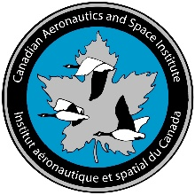 | CASI Roméo Vachon Award Nomination Form
2020

The Roméo Vachon Award

The Roméo Vachon Award was introduced in 1969 by the Canadian Aeronautics and Space Institute in memory of one of Canada's most outstanding bush pilots.
It is presented for outstanding display of initiative, ingenuity and practical skills in the solution of a particular challenging problem or series of challenging problems in aeronautics and space activities in Canada. The achievement for which the award is given shall be of technological nature, particularly practical skills, not necessarily in the scientific or engineering fields. The recipient shall have been a Canadian citizen at the time the contribution was made.
The nomination itself should detail the accomplishments and achievements of the nominee with particular reference to the criteria of the award for which the candidate has been nominated.
The following information should also be included:
- A CV of the candidate
- A short list of publications (if appropriate)
- A minimum of 2 supporting letters, with at least one coming from a person who is external to the candidate’s organization.

(A) Nominator’s Personal Information
First Name: | Middle Name: |  | Last Name:
Address:
Home Phone: ( ) - | Bus Phone: ( ) - |  | Email:
Organization: |  | Title:
Are you a member of CASI | No |  | Yes, CASI Member #:
(B) Candidate’s Personal Information
First Name: | Middle Name: |  | Last Name:
Address:
Home Phone: ( ) - | Bus Phone: ( ) - |  | Email:
Organization: |  | Title:
Is the candidate a member of CASI | No |  | Yes, CASI Member #:

