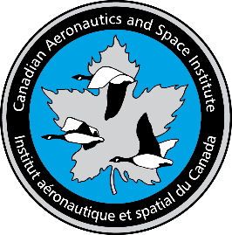
CASI Ottawa Branch Save the Date:
Tuesday November 12 and Wednesday December 4

Trends in the Aerodynamic Test Facility Business
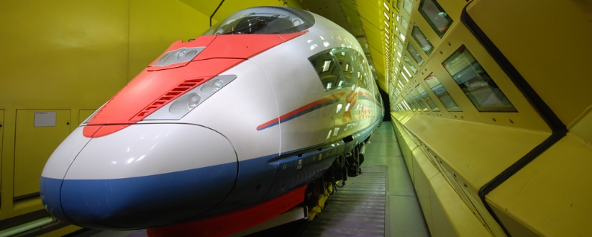
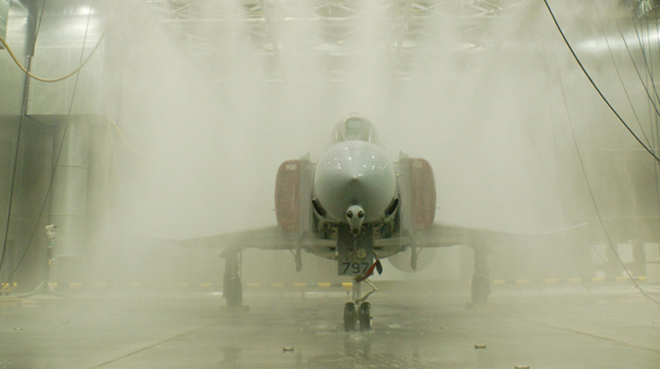
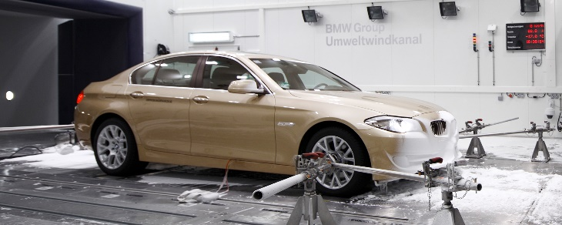

Speaker: Dr. Gary Elfstrom, VP Aiolos Engineering Corporation, Adjunct Professor Ontario Tech University and P. Eng (and NRC Aerodynamics laboratory alumnus)
Why do we need wind tunnels? The presentation will first outline the historical build-up, peaking and a partial demise of wind tunnels in support of aerospace, automotive and other industries. The impact of a rapid build-up of computational methods, including aerodynamics and thermodynamics and, more recently, the synergy of computational and testing methods will be discussed. Finally, the uniquely Canadian success story of wind tunnel testing, design and supply will be given in a parallel historical time line, concluding with some thoughts on what the future may hold.
Come hear some exciting Canadian engineering and business success stories with impact internationally in automotive (cars, trucks, racing, climatic, acoustic, emissions), aeronautical (low and high speed, avian!), and industrial R&D applications. This is the company’s 25th anniversary!
Reference: www.aiolos.com
Dr. Elfstrom has been gracious enough to address our two groups (and timetables):
- Tuesday November 12: uOttawa, 4 pm refreshments and talk
  - uOttawa: Simard Hall Building Room 422- 60 University Private. See www://maps.uottawa/simard-hall
  - Parking next to the building in Lot K- 90 University, or Brooks Garage- 100 Thomas Moore, or Metered street parking
- Wednesday December 4: Carleton, 630 pm
  - Location to be provided.
First preference for CASI members and their guests- RSVP jeffbird99@gmail.com

