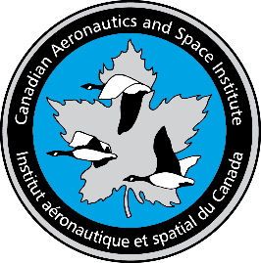
CASI Ottawa Branch December Update
Best wishes for the holidays and a wonder-filled New Year

We appreciate the opportunity to be part of your aerospace and professional community. Here is a short update with sources of information from your membership. Please do continue to participate, offer us your ideas on where we can help and do volunteer (see 1c). Please remember to renew your membership.
- Upcoming Meetings
  - Earth Observation Satellites- System of Systems for international coordination to benefit society, Lunch and learn with Ivan Petiteville, CEOS and ESA (see announcement below)
  - President’s Talk- We are working to arrange a virtual talk with Dr. Harry Kowal
  - CMAS Industry Night: January 12 networking night with Carleton students- Branch members are encouraged to contact us to arrange participation
  - Duke of Edinburgh Sustainability Talk

- Condolences for the sad passing of a CASI gentleman
  - Herb was known and appreciated by so many in the Branch. He taught many of us and influenced our enthusiasm and participation in education and service. Many will remember his great lectures to the branch up until last year and past service on CASI Council including as President. Watch and enjoy the March 2021 podcast at CASI / IASC - CASI Podcasts

- Recent Programs (go and watch them on the CASI podcast: CASI / IASC - CASI Podcasts
  - September: Adopting AR - Augmented Reality for Advanced Composite Structures Repair & Training with Wilson Boynton (updated podcast coming)
  - June: A Canadian's Journey to a Career in Space with Kelsey Doerksen.
  - May: Creating a Resilient Sustainability Strategy: The Pratt & Whitney Story by Avrum Goldman, PWC. The Canadian Aeronautics and Space Institute has for many years enjoyed the support of a Royal Patron – Prince Philip, Duke of Edinburgh. With his passing and recognizing his devotion and initiatives in sustainability, the Ottawa Branch with the support of the CASI Council will present annually an event to advance sustainability for Canada.

- January 2022 Lunch and Learn- Date to be confirmed in latter half of January
Title: CEOS System of Systems
CEOS was established in 1984 in response to a recommendation from a Panel of Experts on Remote Sensing from Space and set up under the aegis of the G7 Economic Summit of Industrial Nations Working Group on Growth, Technology, and Employment. This Panel recognized the multidisciplinary nature of space-based Earth observations and the value of coordinating international Earth observation efforts to benefit society.
Accordingly, the original function of CEOS was to coordinate and harmonize Earth observations to make it easier for the user community to access and use data. CEOS initially focused on interoperability, common data formats, the inter-calibration of instruments, and common validation and inter-comparison of products. However, over time, the circumstances surrounding the collection and use of space-based Earth observations have changed.
This presentation provides an overview of CEOS and shows some examples of the numerous CEOS achievements, thanks to the scientific and technological cooperation of the major space agencies in the world, and the interoperability of their assets.
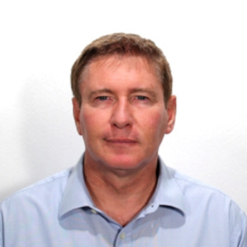
Ivan Petiteville graduated in 1984 from the École Polytechnique (France) where he studied Mathematics and Theoretical Physics. He also owns an engineering diploma in Informatics and Advanced Computer Science from the Ecole Nationale Supérieure des Techniques Avancées (France).
He joined ESA in 1988, first as Principal Ground Segment System Engineer for ERS-1 and then Project Manager of several Earth Observation satellite ground segments.
Since 2000, Ivan has occupied various functions in the Committee for Earth Observation Satellites (CEOS – https://ceos.org ):
• Chair of the CEOS Working Group in Information Systems and Services,
• CEOS Executive Officer,
• Chair of the CEOS Working Group on Disasters between 2011 and 2015, he lead the CEOS Delegation at the 3rd UN World Conference on Disaster Risk Reduction in Sendai (Japan).
In addition, Ivan has taken several roles in the Group on Earth Observations (GEO - https://earthobservations.org/) since its inception in 2005, e.g. co-Chair of GEO Architecture and Data Committee between 2006 and 2012 and co-Chair of the GEO Programme Board from 2018 to 2020.
P.S. Ivan was an inspired stage master’s student at the NRC Engine Lab.

Our best wishes
Omer Majeed, Jeff Bird and Jim Thompson, Ottawa Branch Executive

