Effect of Infill Density on the Mechanical Properties of Additive Manufactured Parts Made from PLA
El Fazani Hayat¹, Austen Erin², Laliberte Jeremy³
hayatelfazani@cmail.carleton.ca
Department of Mechanical and Aerospace Engineering, Carleton University, Canada

Abstract:
The increased use of additive manufacturing in an expanding range of industries has highlighted the need for a better understanding/data of the mechanical performance of 3D printed components with different processing parameters. The aim of this study is to compare the effect of infill density on the mechanical performance of polylactic acid (PLA) test specimens. Standard tensile test coupons were printed from a LulzbotMini 3D printer at a 45º and flat build orientation, using a 2.85 mm diameter PLA filament. Three infill densities of 20%, 60%, and 100% were investigated, all with the default grid infill pattern. The PLA test coupons were subjected to tensile testing until failure using the Materials Testing System (MTS) Dynatron 810 Universal Test Machine to obtain stress and strain curve. The fractured surfaces of the specimens were subsequently examined using optical microscopy analysis to characterize voids distribution. The results demonstrate that increasing the infill density enhances the mechanical tensile performance, with the 100% infill having the highest ultimate tensile strength of 48 MPa and highest tensile stress at yield of 47 MPa. Increasing the infill density also resulted in an increase in the % elongation, with an elongation of 1.55% for an infill density of 100%.
Keywords: PLA, Additive Manufacturing (AM), Fused deposition modelling (FDM), Infill density, Tensile properties.

1. Introduction
Additive manufacturing is an increasingly prevalent manufacturing technology with an ever expanding range of practical applications [1]. Initially used in rapid prototyping, additive manufacturing is increasingly used in producing more final end products across various industries, including aerospace and large structures in civil engineering. As opposed to more traditional subtractive manufacturing methods, additive manufacturing has the distinct capability of producing more geometrically complex components due to the process of adding material layer by layer and not being confined to the limits of the machining process [2][3][4]. This difference in process has the added benefit of minimising material waste while allowing for more lightweight parts to be generated [5][6][7][8]. Additionally, as demonstrated through its initial uses in rapid prototyping, additive manufacturing has the advantage of being easy to modify a part, enabling customisation of components to be fairly straightforward with changes made to the solid model CAD file [9]. This easy customisation of parts has been particularly attractive to the field of biomedical engineering, allowing solutions made from medical-grade materials to be quickly customised to different body shapes and sizes. Furthermore, the uptake of additive manufacturing in 3D printing has resulted in a greater variety of printers and filament materials, making the technology more accessible to all levels of business.
Within additive manufacturing, fused deposition modelling (FDM) is commonly used in many 3D printers, particularly in off-the-shelf models. FDM typically uses plastic filament, although more research industrial grade printers are available which can print using metal or other materials, where the filament is fed through an extruder and exits through a heated nozzle, depositing melted material onto the print bed [10][11][12]. The printer extruder head typically translates along the X-Y coordinates, for cartesian printers, depositing melted polymer material to create a 2-D cross-section of the object, before adjusting it’s vertical or Z-position to begin the next layer. The layers and the corresponding path of the nozzle are determined from the G-Code file, which is a set of instructions for the printer created by slicing a solid model CAD file of the part [13][14]. The functional components of the FDM and the process of building AM components are illustrated in Figure 1.1.

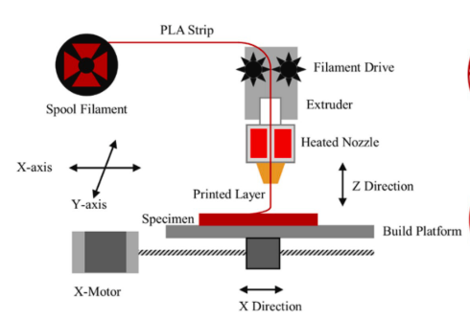
Figure 1.1: Fused Deposition Modelling (FDM) process [15].

The benefits of 3D printing and improvements in material capabilities are discussed in [1]. However, with the expansion of applications resulting in more 3D printed components subjected to mechanical loads, more work is required to evaluate how these parts behave and fail with respect to the material and build properties. In additive manufacturing, there remains a lack of knowledge about FDM parameters such as layer thickness, build orientation, printing speed, infill density, infill pattern, etc.[2][16].
In this experiment, the effect of infill density on mechanical performance was examined for test coupons made of Polylactic Acid (PLA) printed from a LulzbotMini 3D printer. Standard tensile testing using Materials Testing System (MTS) Dynatron 810 Universal Test Machine and optical microscopy analysis were used to evaluate the mechanical performance of the test coupons.

2. Methodology

2.1 Additive Manufacturing Process & Parameters
Tensile “dogbone” specimens were manufactured based on ASTM standard test method for tensile properties of plastics ASTM D638-14, Type I as shown in Figure 2.1 [17]. The three coupons were manufactured using Polylactic Acid PLA Village Plastics, from the same filament spool of 2.85 mm diameter. The samples were printed on flat and at 45º build orientation. To investigate the influence of infill parameters on the tensile properties of PLA material, the 3D printed parts were created with different infill parameters of 20 %, 60 % and 100 %.
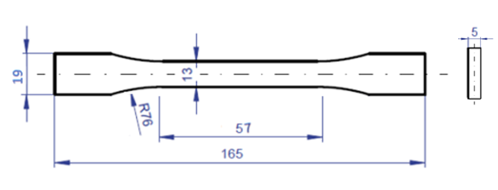
Figure 2.1: Geometry of ASTM D638-10 type I tensile coupons; dimensions in millimeters [17].

The PLA tensile coupons were built using the LulzbotMini machine, as illustrated in Figure 2.2a, using a standard extruder and the high print speed setting. A CAD file was created for the type I tensile coupon. The resulting solid model was then imported into slicing software to produce the required G-Code file for the 3D printer to read and thereby translate into manufacturing the physical test coupon. For the specimens evaluated in this study, the G-Code file was produced using the Cura slicing software. Figure 2.2b shows the test coupon after printing on the print bed of the LulzbotMini 3D printer.
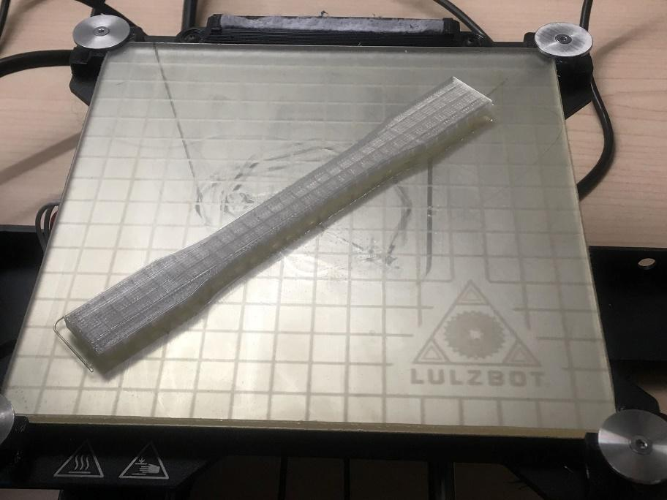
(a) (b)

Figure 2.2: Manufacturing process of PLA tensile coupon. a. LulzbotMini 3D printer, b. PLA coupon after manufacturing.
Upon manufacturing, the PLA parts removed from the bed and metrology was carried out to compare the as-built dimensions to the original STL models. This an essential step before testing the samples. Table 2.1 shows the infill parameters and the samples’ metrology.
Table 2.1: PLA coupons metrology and infill parameters.
Specimen Infill (%) | Thickness (mm) | Area (mm²) | Length (mm)
20 | 4.89 | 65.38 | 164.80
60 | 4.88 | 65.32 | 165.96
100 | 4.87 | 65.50 | 165.91

2.2 Tensile Test Setup & Procedure
The samples were tested using the Materials Testing System (MTS) Dynatron 810 Universal Test Machine, with a capacity of 25kN as shown in Figure 2.3. The samples were gripped with a clamping pressure of 400 Psi. An extensometer with an accuracy of +/- 0.0508 mm was attached to the gage length to record the displacement. After the samples were gripped, the measurement head was moved at a load rate of 5 mm/min and the data collection frequency of 2 Hz, the samples were tested until failure. The applied force and the displacement were collected using FlexTest SE Station Manager computer software. Then the stress was calculated based on dividing the applied force by the average cross-sectional area as shown in Equation 2.1. The strain measurements were obtained based on dividing the change in length over the original length of AM coupon as illustrated in Equation 2.2. The stress strain curve was obtained, and it will be discussed in the discussion section.
σ = F/A (2.1)
ε = ∆L/L_{o} (2.2)
where:
σ: stress (KPa).
F: The axial applied load (kN).
A: The average of the original cross-sectional area (mm²).
ε: Strain.
∆L: The change in length (mm).
L_{o}: The average of original length of the sample (mm).
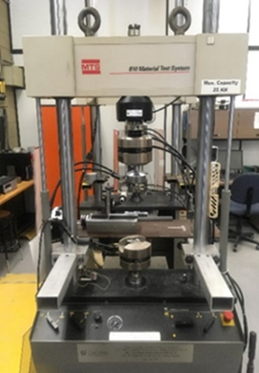
Figure 2.3: 25 KN MTS 810 Material Testing Machine.

2.3 Microscopy Analysis
Upon failure the fracture surface for the PLA tensile coupons was examined using optical microscopy analysis. The samples preparations include cutting the samples using a band saw, mounting the samples in epoxy for solidification, polishing the cross section using automatic polishing (automatic Buehler MetaServ 250). Then, the fractured surfaces were inspected using Olympus model PME 3 microscope. The obtained microscopy images are presented in the result section.
3. Results & Discussion

3.1 Mechanical Properties

The stress- strain relationship for AM coupons made from PLA with infill densities of 20%, 60% and 100% is shown in Figure 3.1. For the AM sample built with 20% infill density, the tensile modulus was calculated to be nearly 2772 MPa. The ultimate tensile strength was recorded to be 26 MPa, while the yield stress was 25 MPa and the elongation at yield recorded to be 1.3%. Since the infill parameter is low, this has caused the sample to fail early compared to the other samples manufactured with 60% and 100% infill densities.

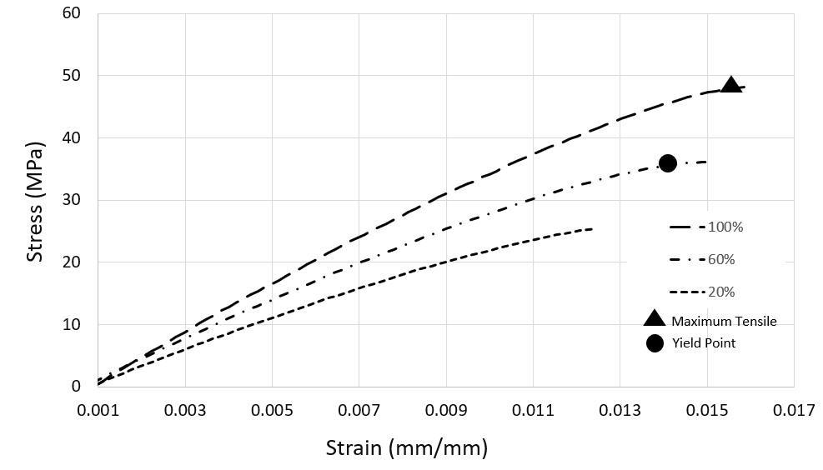
Figure 3.1: Stress-strain curve for AM PLA part manufactured with 20%, 60% and 100% infill densities.

The tensile properties of AM sample manufactured with 60 % in fill parameters were obtained. The tensile modulus was estimated to be 3331 MPa. The highest ultimate tensile strength was observed at 36 MPa. Yield stress was approximately recorded at 35 MPa and the elongation at yield was found to be 1.47 percentage. The tensile modulus for AM PLA part manufactured with 100 % infill parameter was determined to be 4167 MPa. The maximum ultimate tensile strength was approximately 48 MPa, with a yield stress of 47 MPa. The elongation percentage at yield was recorded to be 1.55 %.

The tensile properties values obtained for each infill density are collected in Table 3.1. The normalized tensile properties versus the infill densities are plotted in Figure 3.2. Comparison of infill density with the ultimate tensile strength showed an increasing trend, with the highest ultimate tensile strength of 48 MPa being observed at 100% infill. This positive trend was also observed for increasing infill density and tensile stress at yield, with the lowest tensile stress at yield of 25 MPa observed at 20% infill and the highest value of 47 MPa being observed at 100% infill. Similarly, the tensile modulus and percent elongation at yield also recorded an increase with a higher infill density. The overall increase in each mechanical property with respect to the increase in infill density was expected as it correlates with theory and has been observed in the literature. For instant, an experimental study was conducted to investigate the effect of the infill density for AM PLA parts on the tensile strength [18]. It was found that the variation in the infill parameters has strongly influenced the tensile strength. In addition, the infill structure of AM PLA components was examined in [19]. The study was conducted for different infill densities and topology. The author argued that both infill topology as well as density impacts on mechanical properties.

Upon further examination of the values with respect to percent difference shown in Table 3.1, one can observe that in going from an infill density of 20% to 60%, the 200% increase in infill density corresponds to an increase of 20.2% in the tensile modulus value. The ultimate tensile strength saw an increase of 38.5%, whereas the tensile stress at yield increased by 40.8% when the infill was changed from 20% to 60%. Elongation at yield grew by 13.1% when the infill increased to 60%. From the percent differences calculated, it can be argued that the increase is not uniform across all the mechanical properties. In comparing the 60% infill to the 100% infill, the infill density increased by 66.7%. The tensile modulus increased in value by 25%, while the ultimate tensile strength and tensile stress at yield only grew by 33.3% and 33.5%, respectively. Increasing the infill density from 60% to 100%, resulted in a smaller increase in percent elongation at yield of 5.4%.

Table 3.1: The tensile properties of AM parts made from PLA versus the infill density.
Infill density  (%) | Tensile Modulus  (MPa) | Ultimate tensile strength  (MPa) | Tensile Stress at Yield  (MPa) | Elongation at Yield  (%)
20 | 2772 | 26 | 25 | 1.30
60 | 3331 | 36 | 35 | 1.47
100 | 4167 | 48 | 47 | 1.55

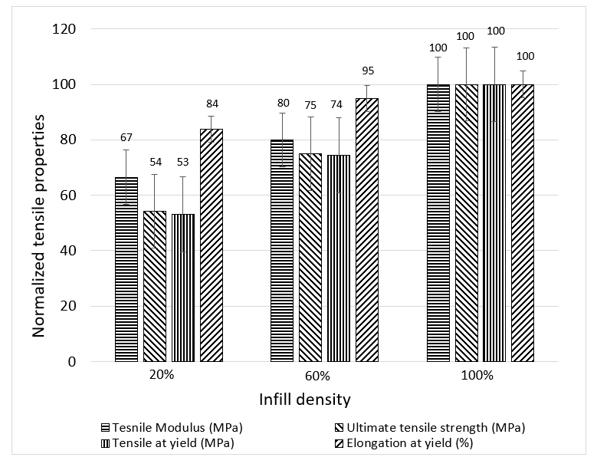
Figure 3.2: Normalized tensile properties for AM PLA parts manufactured with 20%, 60% and 100% infill densities.

3.2 Optical Analysis
Following the tensile testing, the fracture surface of the AM PLA coupons was subjected to optical microscopy analysis. Table 3.2 displays the microscopy images for the AM tensile coupons made from PLA material manufactured at different infill densities of 20%, 60% and 100%. While the images on the first row represent the top view for the microscopy images, the second row shows the cross-sectional view for the fractured surfaces after testing. The representation of these images was made to provide a comparison among the failed samples and to investigate the fracture features such as void size and void distributions. Also, it helps in connecting these observations to the tensile properties results discussed in the previous section.
The optical microscopy images for the AM tensile coupon manufactured with 20% infill density. The white area represents the PLA filaments while the black area represents the voids between the filaments. It can be argued that the lower infill density leads to creating more voids between the PLA filaments. The voids in part manufactured with 20% infill density are found to be higher compared to the other samples manufactured at 60 % and 100 % infill density. The jagged fracture was more evident for the sample created with infill density of 20%, in contrast with the other infill densities of 60% and 100 %. The voids that are associated with the arrangement of filaments in the FDM process were found to have a critical effect on the tensile properties. For example, the ultimate tensile strength for the PLA sample created with 20% infill density was lower than the ultimate tensile strength of the tensile coupon built with 60% infill density. The tensile coupons with the least amount of voids, the 100% infill density is the one that showed the highest value for ultimate tensile strength. The tensile modulus is also improved with reduction of voids between the PLA filaments. The PLA coupons tend to deform elastically. The plastic deformations were different from sample to another. This is due to the variation in the infill density parameter between the samples. The tensile PLA coupons with lower voids experience a higher value of elongation at yield compared to the other two infill density 20% and 60%.

Table 3.2: Microscopy images for AM tensile samples made from PLA material.
Infill Density | 20% | 60% | 100%
Top View Optical Images | 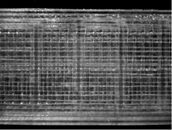  1 mm  Voids  (a) | 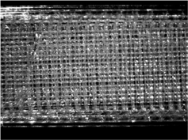  Voids  1 mm  (b) | 1 mm  Voids  (c)
Cross Section View Optical Images | 1 mm  Jagged fracture  (d) | 1 mm  Contour  (e) | 1 mm  Bonded PLA filaments  (f)

4. Conclusions

In this experiment, the effect of the parameter infill density was examined with respect to the tensile mechanical properties of PLA parts produced using the additive manufacturing FDM technique. The PLA components were created using a commercially available LulzbotMini 3D printer. The PLA parts were manufactured with varied infill density 20%, 60% and 100%. The AM coupons were subjected to tensile test, followed by optical microscopy analysis of the fragments. The infill density parameter was found to have a significant effect on the mechanical tensile properties of the AM parts, which was confirmed by the optical microscopy results. The infill density of 100% performed the best with the highest ultimate tensile strength as opposed to the infill density of 20% which tends to be the standard default setting for most 3D printer slicing software. The higher infill’s had less voids, which supports the coupon having better mechanical properties. Thus, it is recommended to build the AM components with 100% infill. However, it was observed that a larger increase in mechanical properties when increasing the infill density from 20 - 60% versus 60 - 100%, suggesting that if cost or weight is of concern, that the infill density should be in the range of 60 - 100%.

5. Future Work
In future work, it is recommended that a higher number of samples be tested for statistical relevance, along with comparing the effect of the infill density across multiple printer models and PLA brands. The authors also recommend expanding this investigation to other 3D printer filaments, including flexible plastics such as NinjaFlex, and then compare the correlation. Furthermore, the effect of infill density should be examined in combination with other parameters such as infill pattern, layer thickness, build orientations, etc. This will assist in determining the optimal parameters for mechanical properties while minimising the weight and/or cost of the component. Finally, it is proposed that future investigations expand on the optical analysis used, to employ Scanning Electron Microscopy (SEM) or Micro Computed Tomography (Micro-CT) to estimate the void fraction and confirm the observed mechanical tensile properties.

Acknowledgements
The authors would like to acknowledge Dr. Julielynn Wong of Medical Makers for providing the LulzbotMini 3D printer and materials. As well, special thanks to the supervisor of the Mechanical and Aerospace Engineering Laboratories at Carleton University, Mr. Steve Truttmann for the technical support and training provided.

References
[1] M. Attaran, “The rise of 3-D printing: The advantages of additive manufacturing over traditional manufacturing,” Bus. Horiz., vol. 60, no. 5, pp. 677–688, 2017.
[2] W. Gao et al., “The status, challenges, and future of additive manufacturing in engineering,” Comput. Des., vol. 69, pp. 65–89, 2015.
[3] C. Weller, R. Kleer, and F. T. Piller, “Economic implications of 3D printing: Market structure models in light of additive manufacturing revisited,” Int. J. Prod. Econ., vol. 164, pp. 43–56, 2015.
[4] B. Vayre, F. Vignat, and F. Villeneuve, “Designing for additive manufacturing,” Procedia CIRP, vol. 3, no. 1, pp. 632–637, 2012.
[5] M. Marya, V. Singh, S. Marya, and J. Y. Hascoet, “Microstructural Development and Technical Challenges in Laser Additive Manufacturing: Case Study with a 316L Industrial Part,” Metall. Mater. Trans. B Process Metall. Mater. Process. Sci., vol. 46, pp. 1654–1665, 2015.
[6] Airbus, “Airbus Technical Magazine,” Flight Airworth. Support Technol., no. 55, p. 34, 2015.
[7] S. Mellor, L. Hao, and D. Zhang, “Additive manufacturing: A framework for implementation,” Int. J. Prod. Econ., vol. 149, pp. 194–201, 2014.
[8] A. Klodowski, H. Eskelinen, and S. Semken, “Leakage-proof nozzle design for RepRap community 3D printer,” Robotica, vol. 33, no. 4, pp. 721–746, 2015.
[9] S. Nelaturi and V. Shapiro, “Representation and analysis of additively manufactured parts,” CAD Comput. Aided Des., vol. 67–68, pp. 13–23, 2015.
[10] J. W. Stansbury and M. J. Idacavage, “3D printing with polymers: Challenges among expanding options and opportunities,” Dent. Mater., vol. 32, no. 1, pp. 54–64, 2016.
[11] B. Rankouhi, S. Javadpour, F. Delfanian, and T. Letcher, “Failure Analysis and Mechanical Characterization of 3D Printed ABS With Respect to Layer Thickness and Orientation,” J. Fail. Anal. Prev., vol. 16, no. 3, pp. 467–481, 2016.
[12] O. H. Ezeh and L. Susmel, “Fatigue behaviour of additively manufactured polylactide (PLA),” Procedia Struct. Integr., vol. 13, pp. 728–734, 2018.
[13] A. C. Brown and D. De Beer, “Development of a stereolithography (STL) slicing and G-code generation algorithm for an entry level 3-D printer,” IEEE AFRICON Conf., pp. 1–5, 2013.
[14] L. Englert, S. Dietrich, and P. Pinter, “Investigations on printing path dependent properties of additively manufactured samples using micro computed tomography,” Rapid Prototyp. J., vol. 26, no. 9, pp. 1603–1614, 2020.
[15] B. Aloyaydi, S. Sivasankaran, and A. Mustafa, “Investigation of infill-patterns on mechanical response of 3D printed poly-lactic-acid,” Polym. Test., vol. 87, no. March, p. 106557, 2020.
[16] D. L. D. Bourell, J. J. Beaman, M. C. Leu, and D. W. Rosen, “A brief history of additive manufacturing and the 2009 roadmap for additive manufacturing: looking back and looking ahead,” Rapid Technol., no. 2, pp. 5–11, 2009.
[17] ASTM International, “Standard test method for tensile properties of plastics,” ASTM Int., vol. 08, pp. 46–58, 2003.
[18] J. C. Camargo, Á. R. Machado, E. C. Almeida, and E. F. M. S. Silva, “Mechanical properties of PLA-graphene filament for FDM 3D printing,” Int. J. Adv. Manuf. Technol., vol. 103, no. 5–8, pp. 2423–2443, 2019.
[19] L. Bergonzi, M. Vettori, L. Stefanini, and L. D’Alcamo, “Different infill geometry influence on mechanical properties of FDM produced PLA,” IOP Conf. Ser. Mater. Sci. Eng., vol. 1038, no. 1, p. 012071, 2021.

