**Development of a Real-time Desktop Flight Simulator for Stratospheric Airships**

**Mohsen Rostami1, Vamshi Chittaluri1, Jafer Kamoonpuri1, Haroon Oqab2,** **George Dietrich2, Joon Chung1\***

1Department of Aerospace Engineering, Ryerson University, Toronto, Ontario, Canada

2Columbiad Launch Services Inc., Kitchener, Ontario, Canada

msn.rostami@ryerson.ca

info@columbiad.ca

j3chung@ryerson.ca

Here, a real-time desktop flight simulator has been developed for the stratospheric airships where beyond the line-of-sight (BLOS) operations are of interest. The proposed stratospheric airship flight simulator (SAFSim) is important to train pilots and increase situational awareness. SAFSim is developed using the FlightGear flight simulator such that it is scalable and low cost. Here, the simulator architecture is described and its application is presented. The flight simulator will allow pilots to accomplish a sizeable portion of real flight tests with the same data transmission techniques in a simulated environment. The main focus is to simulate the flight environment, flight control systems and provide the necessary symbology and data for the pilot to better understand the stratospheric airship performance and operations at high altitudes. SAFsim has been developed as a modular platform to allow further development of the simulator and different kinds and scales of aircraft simulation in the future. The real-time PC-based flight simulator has been developed using the geometry of the airship designed for stratospheric applications along with the corresponding aerodynamics characteristics of the aircraft in the FlightGear flight simulator (FGFS). Furthermore, the buyout forces, added mass, mass balance, ground reactions and propulsion contributions have been considered in the development of the flight simulator. Moreover, the control surfaces functioning as a ruddervator with an X-layout and the capability to provide stability in both longitudinal and lateral-directional directions are bound with the FrSky Taranis X9 radio transmitter. Also, a head-up display has been designed to provide aircraft performance data and environment information on the screen to increase pilots’ situational awareness. Finally, as this simulator is designed to enhance the flight test and training procedures as well, the autopilot features consist of basic modes such as pitch hold and altitude hold developed with the help of PID controllers. Features for data logging and real-time plotting are also available via a “.CSV” output file working in real-time and can be connected to the real-time plotting tools.

**Keywords:** Flight Simulation, Stratospheric Airship, Flight Test, Autopilot, Head-Up Display

---------------------------------------------------------------------------------------------------------------------

1st author Ph.D. Candidate, Department of Aerospace Engineering, Ryerson University, Toronto, Ontario M5B 2K3, CANADA

1* Professor (Corresponding Author), Department of Aerospace Engineering, Ryerson University, Toronto, Ontario M5B 2K3, CANADA

**Introduction**

Lighter-than-air vehicles offer an interesting solution for stationary missions in low and high altitudes. Airships are attractive because they can hover for long periods of time without need to generate lift for large speeds. They can potentially fill the gap between the fixed and rotary wing airplanes and satellites. Accordingly, they have incredible capabilities for missions such as remote monitoring, surveillance, and telemetry by hovering or flying patterns over a specific area for long periods of time, and acting like a satellite. Compared to satellites, they can be easily redeployed to various locations and have a much lower final product and operational cost. These aerial vehicles require much less thrust than conventional aircraft because they gain their lift through buoyancy that allows them to implement sustainable sources with an unlimited flight capability.[1] [2] [3] [4] [5] [6]

Airship platforms are basically working under two very simple physics laws; first, the buoyancy equals the weight at the maximum altitude, and second, the maximum speed is available when the maximum thrust is equal to drag.[7] Autonomous operation and stability requirements are the main challenges for the long time deployment of airships, and flight performance evaluation at different altitudes is a significant progress towards deploying high-altitude hybrid airships.6 A lot has been done to improve the design and development of airships including but not limited to the research projects such as Autonomous Airship of LAAS/CNRS[8] [9] and “LOTTE” airship in Germany[10], “DIVA” in Portugal[11], “KARI” in Korea[12]. Besides, some stratospheric airship technology demonstrations are introduced like HALE-D by Lockheed Martin[13], ISIS by DARPA[14], HiSentinel[15], and Thales Alenia Space by Thales group[16]. The stratospheric lighter than airships are shown in Figure 1.

|  |  |  |
| --- | --- | --- |
| (a) | | (b) |
| (c) | (d) | |

Figure1. Stratospheric airships technology demonstration projects developed to operate at 65,000 to 75,000 ft, a. HiSentinel b. ISIS c. HALE-D d. Thales Alenia Space

Design and development cost of an aerial vehicle may be lowered by modelling and simulation techniques. In addition, simulation environments allow to virtually design, modify and evaluate the performance of an airship and lower the required time/cost to offer a new product. Development of a simulation tool for airships using similar subsystems and modules allows to validate and verify concepts and systems and optimize the entire design. Furthermore, flight performance may be enhanced using flight simulators.[17] Currently, different types and kinds of flight simulators are available offering various capabilities. Desktop platforms are the basic flight simulators and can be enhanced by more sophisticated training simulators and further enhancement will result in advanced X-DOF simulators.[18] A typical simulator uses the flight dynamics model and simulation subsystems and integrates them with a cockpit mock-up, a motion simulation and an outside visual. However, in some cases, an advanced simulator due to strict regulations, may exceed the cost of the real vehicle. So, it is very important to find the optimum point for the cost/benefit ratio and reach an acceptable level of realism. In the case of airships, several studies have been conducted in this area to demonstrate low-altitude operations and investigate the command-and-control subsystems. 17 18 [19] [20] [21] [22] [23]

**The Airship Architecture**

Herein two geometries for the stratospheric airship design are considered. The first architecture, is the high-altitude platform with the mission to carry a payload to an altitude of up to 70,000 ft and remain stationery for a long time. The precise sizing characteristics are not the purpose of this work. The stratospheric airship is equipped with two electrical engines, both placed at ~30% of the airship length from nose as shown in Figures 2 and 3. The engine placement allows the airship to use thrust vectoring to generate sufficient pitch and yaw moments. The hybrid architecture is designed to employ a communication system with the help of solar panels, fuel cells, and batteries and stay stationary for a long time. The hull uses a circular cross section multi-ellipsoid geometry, and the tail has a cross shaped four-fin empennage configuration (X-layout) with inflated fixed fins and the ruddervector configuration to provide stability in both longitudinal and lateral-directional directions.

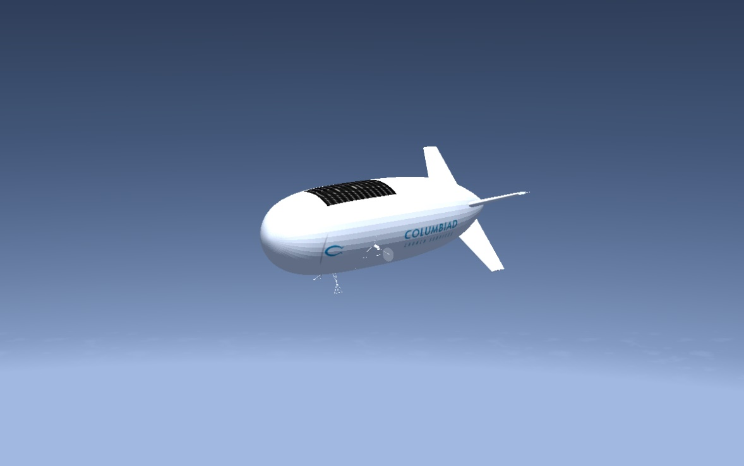

Figure 2. The stratospheric airship equipped with two electrical engines flying at 70,000ft

The second geometry is a scaled down version of the main architecture to carry the payload to 10,000 ft and corresponding to the low-altitude demonstrator designed for validation of control and navigation systems. The low-altitude airship is presented in Figure 2 with different parameters described in Table 1.

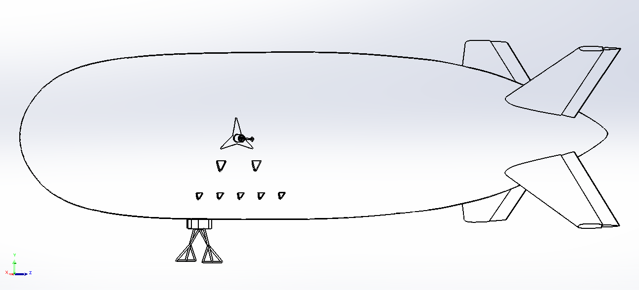

Figure 3. The low-altitude airship demonstrator geometry

Table 1. Airship geometry parameters

|  |  |  |
| --- | --- | --- |
| **Variable name** | **Value** | **Description** |
| dmax | 5.2 m | Maximum hull diameter |
| fr | 3.85 | Fineness ratio |
| XCG | 8.8 m | Center of gravity location from nose |
| XCB | 8.8 m | Centre of buoyancy location from nose |
| ZCG-CB | 1 m | Vertical distance between CG and CB (CG below CB) |
| lairship | 20 m | Total Airship Length |
| me | 170 Kg | Empty mass |
| Sf | 5.9 m2 | Fin Reference Area |
| Sh | 21.2 m2 | Hull Reference Area |
| Vol | 300 m3 | Hull Volume |
| Tmax | 20.4 Kg | Maximum Engine Thrust (Each) |

**The Real-time Flight Simulation**

SAFSim is a flight simulator developed for the stratospheric hybrid airship where BLOS operations are of interest.[24] The proposed flight simulator is structured as a modular platform using the FGFS such that it is scalable and low cost. Hence, different kinds and scales of the airship architecture can be easily simulated via SAFSim to study the behaviour of the design at various altitudes and flight conditions. To set up SAFSim’s architecture, the geometry of the airship described in Table 1 was modeled in FGFS using the Flight Dynamics Model (FDM) provided by JSBSim. Accordingly, the corresponding aerodynamic characteristics of the hybrid airship along with the buyout forces, added mass, mass balance, ground reactions, atmosphere and propulsion contributions were considered in the development of the flight simulator. This information is gathered in separate Extensible Markup Language (XML) configuration files to enable the modular platform for the flight simulator architecture.

The lift of the airship is essentially provided by the hybrid system comprising of helium, inside the hull and fixed fins, for the aerostatic lift and the two propeller-driven electric engines for the thrust. Also, the stratospheric hybrid airship is equipped with a ballonet, which is controlled by a common pneumatic system of pipes and valves. The ballonet can be blown up with air and deflated, during the descent and climb operations, respectively to control altitude variations without lose of helium inside the hull and to avoid any substantial alteration in the shape of hull. In fact, the variable amount of air inside the ballonet compensates the volume fluctuations of the helium during altitude variations. Moreover, the tail uses cross shaped inflated fixed fins along with the ruddervector control surfaces to provide the longitudinal and lateral-directional stability in different flight regimes. Mass balance uses mass of the hybrid airship to provide a force due to gravity and moments of inertia to damp changes in rotational velocity. Empty mass and inertia were specified in this model. Ground reactions has a fairly simple system using the structural contacts which are modeled as a force on the vehicle when in contact with the ground. If the contact is not at the centre of mass, it also provides a rotating moment.

The control surfaces were bound with the FrSky Taranis X9 radio transmitter through a Wireless USB Dongle to transfer pilot’s commands and control the airship during flight. Also, a Head-Up Display (HUD) were designed to provide aircraft performance data and environment information on the screen as shown in Figure 4 to increase pilots’ situational awareness.

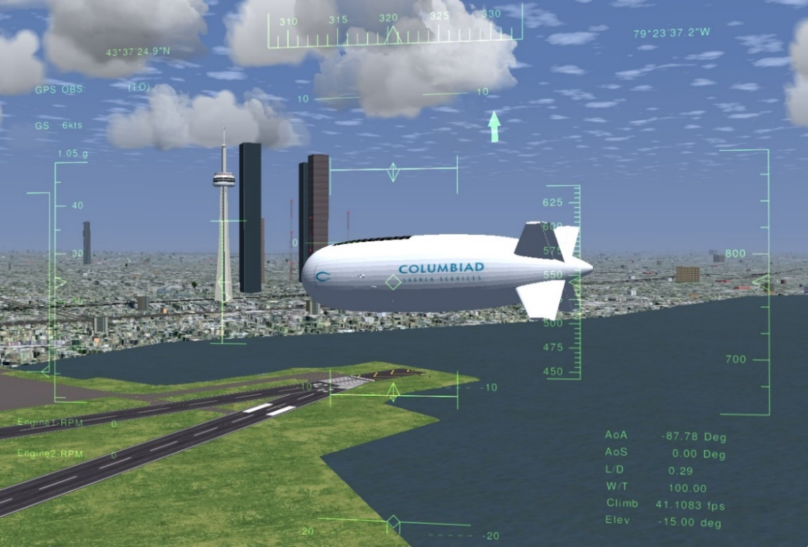

Figure 4. The HUD elements presented on the screen of the FGFS to increase pilots’ situational awareness

Figure 5. shows a simplified process flow of how SAFSim flight data and simulation are handled. The Airship simulator receives flight input from JSBSim and the FrSky Taranis X9 radio transmitter to control the simulated airship, at the same time an extra script records the flight data and controller data and exports them in a single CSV file in real-time. The HUD elements are also updated in real-time in SAFSim.

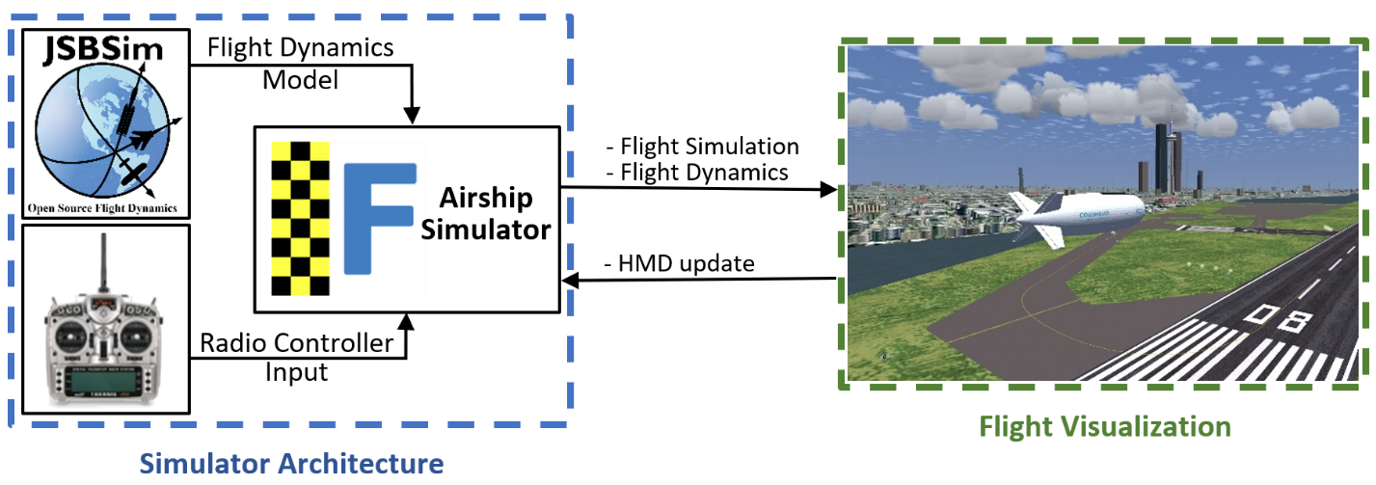

Figure 5. Simplified flowchart describing the process of displaying real-time flight information onto the SAFSim flight simulator

**Results and discussion**

The resulting flight simulation view of the proposed SAFSim simulator described in Figure 5 is presented in Figure 6 for different POVs. As SAFSim was developed in the environment of the FGFS, the user can choose, organise or modify the graphical modes using the available setup menus and camera views, such as from the control tower, from the cockpit and from different positions from the airship, as shown in Figure 6.

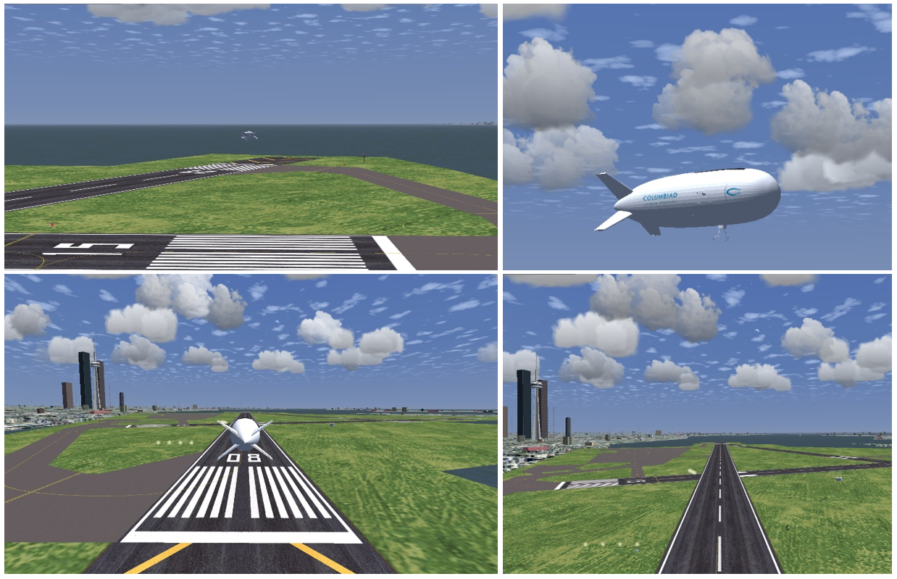

Figure 6. Different camera views within the SAFSim simulator developed using the FGFS

SAFSim provides an enhanced simulation tool for the design, development and test of lighter than air vehicles at various altitudes. Flight environment, flight control systems and the necessary symbology and data provided by SAFSim allows to better understand the stratospheric airship performance and operations at different altitudes. SAFsim was developed as a modular platform to allow further development of the simulator and different kinds and scales of aircraft simulation. In particular, to perform realistic hardware-in-the-loop simulations, the SAFSim Simulator was organized in three separate entities, properly connected in the FGFS environment, which completely define the airship system. The three entities are the airship model defined in the FGFS, the flight dynamics from JSBSim and the radio transmitter device.

As SAFSim is designed to enhance the flight test and training procedures, the autopilot features consist of basic modes such as pitch hold and altitude hold developed with the help of PID controllers. Features for data logging and real-time plotting are also available with a “.CSV” output file working in real-time and can be connected to the real-time plotting tools. An important factor to be considered here is the frequency FGFS logs data on the CSV file. If the frequency is too high it can place a significant load on the PC which will affect the performance of any application running at the time. If the frequency is too low then the data received by the user will be too outdated to use and the transmission cannot be considered real-time. A balance was found for the FGFS to write to a CSV at a period of 0.1s.

SAFSim can also be seen as a Ground Control Station (GCS) prototype, and it is conceived to completely define the GCS concept and transmit flight information as well as Point of View (POV) visuals in real-time via a Virtual Reality Head-Mounted Display (VR-HMD). The VR-HMD GCS allows to create a system that can connect SAFSim to a wireless VR-HMD and transmit flight information as well as POV visuals in real-time. In addition to the simulated environment, the real images broadcasted by the onboard video-cameras may be integrated with synthetic scenario, using the same concept developed for the SAFSim Simulator. This arrangement is conceived in order to provide the pilot with a rear observer POV, such as the one shown in the left image of Figure 6. This view proved to be particularly useful in remotely piloting, when the pilot has no direct feelings of the aircraft attitude and movement. The VR-HMD simulator allows pilots to accomplish a sizeable portion of real flight tests with the same data transmission techniques in a simulated environment.

Figure 7 shows the VR headset connected to the SAFSim simulator that is bound to the FRSky Taranis RC controller. The proposed system uses third-party streaming applications such as Virtual Desktop and ALVR to stream live footage of the Unity Game Engine based custom VR application including the flight simulator over Wi-Fi to the wireless standalone HMD. The radio controller including real-time orientation/state of each button was also simulated to provide better awareness to the pilot and reduce the need to take off the HMD. Moreover, a Head-Up Display was designed in accordance with the human factor requirements and the general usability of the system to provide the essential flight information for pilots.

|  |  |
| --- | --- |
| (a) | (c) |
| (b) |
| Figure 7.a. The graphical model of an Oculus Quest VR headset b. The FRSky Taranis RC controller model c. The simulated flight that was integrated with the VR-HMD to provide the GCS capability | |

**Conclusion**

This paper presents the design of a flight simulator called SAFSim for stratospheric airships to visualize airships flight in a simulated environment in real-time. The purpose of such a system is to study the flight of stratospheric airships in BLOS scenarios. In this work, the desktop flight simulator was developed using the geometry of the airship designed for stratospheric applications along with the corresponding aerodynamics characteristics of the aircraft in the FGFS. Furthermore, the buyout forces, added mass, mass balance, ground reactions and propulsion contributions were all considered in the flight simulator development. Moreover, the control surfaces functioning as a ruddervator with an X-layout and the capability to provide stability in both longitudinal and lateral-directional directions were bound with the FrSky Taranis X9 radio transmitter.

**Acknowledgments:** This work was supported by Mitacs through the Mitacs Accelerate Program (reference number: IT16648) and Columbiad Launch Services Inc.

1. C. J. Miller, J. Sullivan, and S. McDonald, “High altitude airship simulation control and low altitude flight demonstration,” Collect. Tech. Pap. - 2007 AIAA InfoTech Aerosp. Conf., vol. 1, no. May, pp. 544–565, 2007
2. J. B. Mueller, M. A. Paluszekt, and Y. Zhao, “Development of an aerodynamic model and control law design for a high-altitude airship,” Collect. Tech. Pap. - AIAA 3rd “Unmanned-Unlimited” Tech. Conf. Work. Exhib., vol. 1, no. September, pp. 415–431, 2004
3. M. Battipede, P. Gili, and M. Lando, “Ground station and flight simulator for a remotely-piloted non conventional airship,” Collect. Tech. Pap. - AIAA Guid. Navig. Control Conf., vol. 5, no. August, pp. 3660–3671, 2005
4. M. Battipede, P. A. Gili, M. Lando, and L. Massotti, “Flight simulator for the control law design of an innovative remotely-piloted airship,” Collect. Tech. Pap. - AIAA Model. Simul. Technol. Conf., vol. 1, no. August, pp. 181–194, 2004
5. P. Peddiraju, T. Liesk, and M. Nahon, “Dynamics modeling for an unmanned, unstable, fin-less airship,” 18th AIAA Light. Syst. Technol. Conf., no. May, 2009
6. J. S. A. Santos, L. C. S. Góes, and R. S. Pant, “Design and flight testing of an autonomous airship,” 22nd AIAA Light. Syst. Technol. Conf. 2015, no. June, 2015
7. A. Ceruti, V. Voloshin, and P. Marzocca, “Heuristic algorithms applied to multidisciplinary design optimization of unconventional airship configuration,” J. Aircr., vol. 51, no. 6, pp. 1758–1772, 2014.
8. S. Lacroix, I. K. Jung, P. Soueres, E. Hygounenc, and J. P. Berry, “The autonomous blimp project of {LAAS/CNRS} - Current status and research challenges,” Proceeding Int. Conf. Intell. Robot. Syst. IROS, Work. WS6 Aer. Robot., pp. 35–42, 2002
9. E. Hygounenc, I. K. Jung, P. Souères, and S. Lacroix, “The autonomous blimp project of LAAS-CNRS: Achievements in flight control and terrain mapping,” Int. J. Rob. Res., vol. 23, no. 4–5, pp. 473–511, 2004
10. P. Funk, T. Lutz, and S. Wagner, “Experimentelle investigations on hull-fin interferences of the LOTTE airship,” Aerosp. Sci. Technol., vol. 7, no. 8, pp. 603–610, 2003
11. A. B. Moutinho, “Modeling and Nonlinear Control for Airship Autonomous Flight,” Thesis PhD, no. August, p. 178, 2007
12. Y. G. Lee, D. M. Kim, and C. H. Yeom, “Development of Korean high altitude platform systems,” Int. J. Wirel. Inf. Networks, vol. 13, no. 1, pp. 31–42, 2006.
13. S. Androulakakis, “Lockheed Martin Lighter-Than-Air Programs”, JPL / Caltech Airship Workshop, Keck Institute for Space Studies, 2013
14. P. Lobner, “DARPA Integrated Sensor is Structure (ISIS) airship”, 2020
15. I. S. Smith, “HiSentinel & Stratospheric Airship Design Sensitivity”, Southwest Research Institute, KISS Workshop, 2013
16. Thales Group official website, URL: <https://www.thalesgroup.com/en/worldwide/space/news/whats-stratobus>
17. L. Sofia and N. Martins, “Development of a Flight Simulation Training Device and Remote Pilot Station: The URBLOG Unmanned Hybrid Airship Vehicle Case,” 2020
18. A. Robinson, K. Mania, and P. Perey, “Flight simulation: Research challenges and user assessments of fidelity,” Proc. VRCAI 2004 - ACM SIGGRAPH Int. Conf. Virtual Real. Contin. its Appl. Ind., vol. 1, no. 212, pp. 261–268, 2004
19. B. E. Kashawlic and J. F. Keller, “Spatial wind modeling for lighter than air vehicles,” AIAA Model. Simul. Technol. Conf. 2010, no. August, pp. 1–9, 2010.
20. A. J. J. Lemmers and A. P. L. A. Marsman, “A basic flight simulation tool for rigid airships A basic flight simulation tool for rigid airships,” Environment, 2000.
21. J. LOWE and J. DELAURIER, “A six-degree of freedom heavy lift airship flight simulation,” 1983.
22. N. BENNETT and N. RAZAVI, “Flight testing and operational demonstrations of a modern non-rigid airship,” pp. 6–9, 1983.
23. H. R. Jex, R. E. Magdaleno, and W. A. Johnson, “LTASIM: A desktop nonlinear airship simulation,” 9th Light. Syst. Technol. Conf. 1991, vol. 1, pp. 34–42, 1991.
24. M. Rostami, J. Chung, “Development of an Enhanced Ground/Air Control Station Equipped with an Advanced Virtual Reality Headset for Stratospheric Airships Applications in Satellite-Denied Environments”, CASI ASTRO 2020, Toronto, ON, Canada, 2020, DOI: 10.13140/RG.2.2.20401.92008