Damage Modelling of a Laminated Composite Panel Subjected to Low Velocity Impact

Gang Li∗, Yunfa Zhang

Aerospace Research Centre
National Research Council of Canada, Ottawa, Ontario, Canada K1A 0R6

Abstract
Three-dimensional finite element models were developed to simulate the low velocity impact of a laminated fibrous composite panel in cross-ply configuration. Two simulation scenarios including intra-laminar failure and a combination of intra- and inter-laminar failures were conducted. Three-dimensional elements with Hashin’s damage criteria were applied to simulate the intra-laminar failure including matrix cracking and fibre breakage. Moreover, cohesive elements were employed to simulate inter-laminar failure (delamination) between the plies. The impact responses in the force versus time curve and the associated failure behaviour were predicted for a carbon fibre reinforced polymer laminate and the numerical results were compared with the experimental results.
Keywords: Composite laminates; Damage; Finite element analysis; Low velocity impact

1. Introduction
Advanced composite materials have high specific stiffness and strength and hence are widely used to enhance the performance of ground vehicles, aircrafts, personal protective equipment (PPE), and so on. [1-3]. In many of these applications, the impact performance of the composites is a major concern to be addressed. The experimental assessment of impact properties is a reliable evaluating method. However, obtaining performance data through experiments is costly, time consuming, and sometimes impractical. Therefore, the establishment of a computational modelling capability for analyzing relevant materials, components, and/or structures with limited test data under specific configurations is appealing for assessing and designing end-products. Numerical modelling is considered to be the most efficient way to simulate the impact response and to assess damage evolution spatially and transiently throughout the impact period. The numerical method is also convenient for parametric studies such as under different boundary conditions. Numerous studies have been conducted to study the low velocity impact response of laminated composite panels through testing, theoretical analysis, and numerical modelling. From the open literature, it is noticed that experimental testing is expensive and time consuming [4-7]. Theoretical studies are only applicable to certain conditions due to individually idealized assumptions [8-11], and the finite element (FE) modelling approach was found to be a powerful and cost-effective tool for such studies [12-21].
As demonstrated in the work cited above, during low velocity impact, contact occurs over a relatively long period for the structure to respond, and hence it absorbs more energy than a comparable high velocity impact. The physical phenomena are very complicated involving dynamic loading and structural effect, contact, friction, damage onset and evolution, failure, etc. The typical damage modes exhibited are a combination of inter-laminar and intra-laminar damages. The inter-laminar damage refers to delamination between two consecutive plies or layers. The cohesive zone model (CZM) can be applied to study the inter-laminar delamination induced by impact [13-21]. A cohesive traction-separation law with an enclosed area that represents the material’s critical strain energy release rate, combined with damage criteria and damage evolution law, is usually used to govern the cohesive element behaviour. The intra-laminar damage consists of matrix cracking, fibre/matrix debonding, and fibre breakage. The relevant damage onset can be studied based on the 3D Hashin’s criteria or modified criteria in terms of material strengths which have been widely applied to predictions [12-22]. The associated damage evolution can be well described via concepts in continuum damage mechanics [23-25], in which a customized user subroutine on representative damage criteria with material mechanical parameters is preferred for achieving practical predictions of the impact force versus time curve and the damage onset and evolution behaviour [19, 20, 22, 24-26, 30]. Recently, an examination review on the prediction capability of six representative analysis approaches with different abstraction scales was reported [26]. The work concluded that high fidelity finite element simulations should be carried out using 3D solid models: the 3D stacked layer model and the 3D ply-splitting model. A pre-condition for the advanced 3D ply-splitting model is that the element edges in the ply mesh align with the fibre orientation, and appropriate cohesive parameters should be specified to the cohesive elements. The above literature review showed that there was limited predicted information available on the local failure in a 3D condition, considering the effects of material parameters and cohesive element locations.
In this paper, three-dimensional finite element models aimed to simulate the low velocity impact response of composite laminates with relevant local damages are described. The models were established using Abaqus/CAE (version 6.14r2) and the composite panel plies were meshed using 3D solid elements. Two simulation scenarios were studied: (i) intra-laminar failure, and (ii) mixed intra- and inter-laminar failure. The intra-laminar failure was assessed using Hashin’s damage criterion implemented in a user-defined subroutine for the material, and the inter-laminar delamination modelling was carried out employing cohesive elements. In the second scenario, three different panel models were evaluated. These models were meshed using solid elements for each ply but with cohesive elements between the plies at different locations. Numerical results for a carbon fibre/epoxy laminate were presented and compared with the experimental results.

2. Experimental Aspect
Carbon fibre/epoxy laminate specimens were manufactured with a total of 12 plies with dimensions of 114.3×114.3×2.2 mm. The two outer layers of the composite specimens were 2x2 twill fabrics of 210 g/m² woven carbon fibres (CF) with an epoxy resin, and each outer layer has only one [0/90] fabric with a thickness of 0.2 mm. The core of the panel was a 10-ply laminate in [0/90/0/90/0]_{s} layup made of 190 g/m² 12K unidirectional (UD) carbon fibre and an epoxy resin, where each ply had a thickness of approximately 0.18 mm. Some in-plane mechanical properties for both the skin (CF fabric) and core laminate CF UD) were provided by the material supplier, ACP Composites. Specifically, the twill fabric composite material properties given by the manufacturer were: $E_{1}=E_{2}$ = 70 GPa (in-plane Young’s modulus), G₁₂ = 5 GPa (in-plane shear modulus), v₁₂ = 0.1 (in-plane Poisson’s ratio) , σ_{1t} =σ_{2t} = 600 MPa (tensile strength in 0° and 90° directions), ε_{1t} = ε_{2t}= 0.85% (ultimate tensile strain in 0° and 90° directions), σ_{1c}=σ_{2c} = 570 MPa (compressive strength in 0° and 90° directions), ε_{1c} = ε_{2c} = 0.8% (ultimate compressive strain in 0° and 90° directions), S₁₂= S₂₁ = 90 MPa (in-plane shear strength), and γ₁₂ = γ₂₁ = 1.8% (in-plane ultimate shear strain). The subscript of the material parameter 1 refers to the fibre direction, 2 refers to the 90⁰ direction relative to the fibre orientation, and 3 refers to the thickness direction.
A low velocity impact test at a 1 m/s was carried out using the test setup shown in Figure 1. The composite panel was centrally positioned and then clamped between two square aluminium plates with a central hole with a radius of 38.1 mm. Both aluminium plates had a thickness of 10 mm. The impact indenter was a 12.7 mm diameter cylindrical section with a hemi-spherical nose, made of high-strength steel. The indenter was installed into an MTS high-speed load frame (model 318.255) to impact the laminates. This load frame has a load capacity of 250 kN (55 kip) and a 98 kN (22 kip) actuator. The control loop of the high speed load frame maintains a constant velocity during each impact test. The impact force versus time variation data was recorded using a data acquisition system with a sampling rate of 50 kHz. Figure 2 shows typical impact force versus time curves obtained for two repeated tests. Both were impacted at 1 m/s and the measured peak forces were approximately 2.3 kN and 2.6 kN over a duration of 0.016 second.

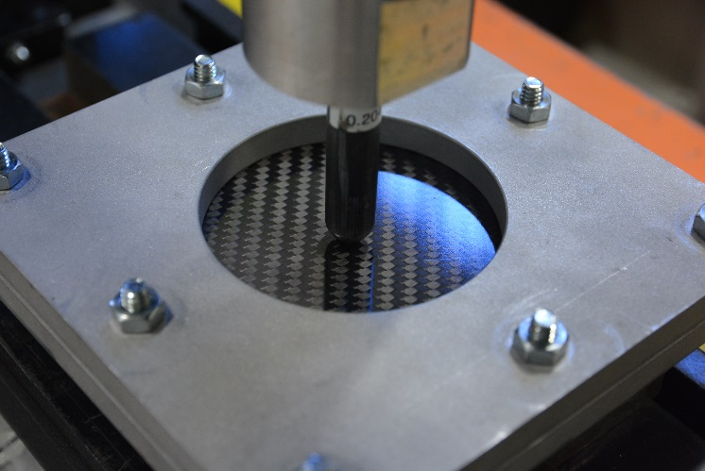

Figure 1. The clamped composite specimen and its impactor in the low velocity impact test.

Figure 2. Variation of impact force-time curves obtained from the tests at 1 m/s impact velocity.

3. Modelling Impact Response without Considering Delamination
The FE model consisted of a laminated composite panel and a hemispherical steel indenter dimensionally consistent with the test apparatus. In order to connect the two parts under impact, a surface-to-surface (including interior body of the laminate) contact pair was place at the indenter-to-laminate, and the laminate self-contact features were employed within the laminate. To simulate the boundary conditions of the experimental clamping of the composite panel between the two aluminium plates, zero displacement in three directions, $u_{x}$, $u_{y}$, and $u_{z}$, was assumed in the clamped region adjacent to the frame support. A constant impact velocity $V_{z}$ component was applied to a reference point that was attached to the indenter via a rigid body constraint condition. The rigid body assumption for the indenter is acceptable due to the very small deformation of the steel indenter during the test [27].

3.1. The Meshed Model of Laminated Panel
The panel model was first meshed with 3D stress elements only, without any cohesive zone layers. Consequently, this model can only simulate the ply intra-laminar failure without delamination damage. Figure 3 shows the FE model meshed by 3D stress elements, C3D8R and C3D6.

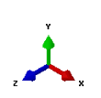
(a) | (b)
(c) | (d)
Figure 3. The model for the laminated composite panel with 12 layers meshed with stress elements: (a) the indenter and the partitioned panel, as well as the clamped outer sheet region outside the 38.1 mm radius; (b) overall mesh condition; (c) close-view of the meshed indenter and the panel central area, and (d) an unobstructed view of the mesh at the central area of the panel.
The 12-layer laminated panel model was created based on the nominal coupon dimensions, with each ply orientation specified using a local coordinate system, such that the element’s xy plane was parallel to the panel. Hence, $E_{11}^{0}$ was in the fibre direction, $E_{22}^{0}$ was in the transverse 90° direction to the fibre within the plane, and $E_{33}^{0}$ was in the out-of-plane direction. Eight concentric circular partitions around the sheet centre with radii of 3.175, 4.7625, 6.35, 8.35, 18.35, 38.1, 40.1, and 42.1 mm were created to provide a fine meshes in both the central part and the supported region near the clamped edge. The region beyond the 38.1 mm radius was clamped area of the test setup. Based on different mesh trials, a mesh scheme with an element for each ply in the thickness direction was employed for the composite panel. A total of 8616 elements (8184 linear hexahedral C3D8R elements and 432 linear wedge C3D6 elements) were used with 12 elements in the panel through thickness depth. As a result, the largest elements in the panel plane had dimensions of approximately 15×15 mm and were located at the four corners at the outside edge. The smallest elements in size had dimensions of approximately 0.45×0.45 mm and were positioned in the centre of the sheet where the impact area was located. The indenter part chosen in the model consisted of a 6.35 mm long cylinder section attached to a hemi-spherical contact nose with the same 6.35 mm radius. The mesh seeds used for the indenter were: 40 equal elements distributed along the cylinder (and hemi-sphere) outer perimeter, 20 elements set to the arc length of the contact nose from the cylinder end section to the end point of the hemi-spherical nose, and 7 elements assigned to the cylinder section along its length. A total of 12263 three-dimensional linear tetrahedron C3D4 elements were created to model the indenter. It also had a fine mesh with a minimum element length of approximately 0.45 mm at the nose end.

3.2. Material Parameters and Failure Criteria
The linear elastic material properties with density $ρ=$7800 kg/m³, Young’s modulus $E=$ 210 GPa, and Poisson’s ratio $v=$0.27 were used for the steel indenter. A total of four material sets, “mat-set” 1 to 4, were implemented in the simulations for the skin and the uni-directional carbon fibre/epoxy lamina core material. In order to input all parameters required by the 3D numerical assessment, some parameters related to the thickness direction were assumed. Also, some parameters were adjusted using moderately higher values in view of possible variations in material properties. Table 1 lists “mat-set 1” based upon the material parameters provided in the manufacturer’s material reference data. Table 2 lists three other material sets. The second set, “mat-set 2”, was an adjusted set based upon “mat-set 1” with selected parameters increased. The third set, “mat-set 3”, was defined based upon the in-house test results for the core material. The fourth set, “mat-set 4”, contains estimated values based upon both “mat-set 2” and “mat-set 3” as a result of selecting higher values of some parameters.

Table 1. Material mechanical parameters, “mat-set 1” from the manufacturer
Material | Mechanical parameters | Source | Parameters for FE modelling | Material set defined for the FE analysis
Skin: Carbon fibre, twill, fabric | $E_{1}=E_{2}=$70 GPa, $G_{12}=$5 GPa, $v_{12}=0.1$, $σ_{1t}=σ_{2t}=$600 MPa, $σ_{1c}=σ_{2c}=$570 MPa, $S_{12}= S_{21}=$ 90 MPa. | ACP | $ρ=$ 1600 kg/m³ (density), $E_{11}^{0}=E_{22}^{0}=$70 GPa, $E_{33}^{0}=$ 9 GPa, $G_{12}^{0}=G_{13}^{0}=$5 GPa, $G_{23}^{0}=$3.5 GPa,$v_{12}=v_{13}=0.1$, $v_{23}=0.2$, $σ_{1t}=σ_{2t}=$600 MPa, $σ_{1c}=σ_{2c}=$570 MPa, $σ_{3t}=σ_{3c}=$ 300 MPa, $S_{12}= S_{21}=S_{23}=$90 MPa. | “mat-set 1”
Core: CFRP | $E_{1}=$135 GPa, $E_{2}=$10 GPa, $G_{12}=$5 GPa, $v_{12}=0.3$, $σ_{1t}=$1500 MPa, $σ_{1c}=$ 1200 MPa, $σ_{2t}=$50 MPa, $σ_{2c}=$ 250 MPa, $S_{12}=$70 MPa. |  | $ρ=$ 1600 kg/m³ (density), $E_{11}^{0}=$135 GPa, $E_{22}^{0}=E_{33}^{0}=$ 10 GPa, $G_{12}^{0}=G_{13}^{0}=$5 GPa, $G_{23}^{0}=$3.5 GPa, $v_{12}=v_{13}=$ 0.31, $v_{23}=$0.45, $σ_{1t}=$1500 MPa, $σ_{1c}=$1200 MPa, $σ_{2t}=$150 MPa, $σ_{2c}=$1000 MPa, $σ_{3t}=σ_{3c}=$ 300 MPa, $S_{12}= S_{21}=S_{23}=$ 90 MPa.

Table 2. Additional three sets of the material mechanical properties used in the simulations.
Material | Parameters for FE modelling | Material set defined for the FE analysis
Skin: Carbon fibre, twill, fabric | $ρ=$ 1600 kg/m³, $E_{11}^{0}=E_{22}^{0}=$120 GPa, $E_{33}^{0}=$ 12 GPa, $G_{12}^{0}=G_{13}^{0}=G_{23}^{0}=$ 5 GPa, $v_{12}=v_{13}=v_{23}=0.1$, $σ_{1t}=σ_{2t}=$ 1200 MPa, $σ_{1c}=σ_{2c}=$570 MPa, $σ_{3t}=σ_{3c}=$ 450 MPa, $S_{12}= S_{21}=S_{23}=$ 120 MPa. | “mat-set 2”
Core: CFRP | $ρ=$ 1600 kg/m³, $E_{11}^{0}=$135 GPa, $E_{22}^{0}=E_{33}^{0}=$ 12 GPa, $G_{12}^{0}=G_{13}^{0}=$5 GPa, $G_{23}^{0}=$2.5 GPa, $v_{12}=v_{13}=$ 0.31, $v_{23}=$0.45, $σ_{1t}=$1500 MPa, $σ_{1c}=$1000 MPa, $σ_{2t}=$ 90 MPa, $σ_{2c}=$250 MPa, $σ_{3t}=σ_{3c}=$ 450 MPa, $S_{12}= S_{21}=$ 120 MPa. $S_{23}=$ 90 MPa
Skin: Carbon fibre, twill, fabric (referenced from its data sheet) | $ρ=$ 1600 kg/m³, $E_{11}^{0}=E_{22}^{0}=$70 GPa, $E_{33}^{0}=$ 8 GPa, $G_{12}^{0}=G_{13}^{0}=$ 5 GPa, $G_{23}^{0}=$ 3.5 GPa, $v_{12}=v_{13}=v_{23}=0.1$, $σ_{1t}=σ_{2t}=$ 1200 MPa, $σ_{1c}=σ_{2c}=$570 MPa, $σ_{3t}=σ_{3c}=$ 450 MPa, $S_{12}= S_{21}=$ 110 MPa. $S_{23}=$ 90 MPa. | “mat-set 3”
Core: CFRP (test data in bold) | $ρ=$ 1600 kg/m³, $E_{11}^{0}=$123 GPa, $E_{22}^{0}=E_{33}^{0}=$ 8 GPa, $G_{12}^{0}=G_{13}^{0}=$4.41 GPa, $G_{23}^{0}=$3.64 GPa, $v_{12}=v_{13}=$ 0.31, $v_{23}=$0.45, $σ_{1t}=$2100 MPa, $σ_{1c}=$1120 MPa, $σ_{2t}=$ 66.25 MPa, $σ_{2c}=$138 MPa, $σ_{3t}=σ_{3c}=$ 450 MPa, $S_{12}= S_{21}=$ 90 MPa. $S_{23}=$ 50 MPa
Skin: Carbon fibre, twill, fabric (the same as the mat-set 2) | $ρ=$ 1600 kg/m³, $E_{11}^{0}=E_{22}^{0}=$120 GPa, $E_{33}^{0}=$ 12 GPa, $G_{12}^{0}=G_{13}^{0}=G_{23}^{0}=$ 5 GPa, $v_{12}=v_{13}=0.1$, $v_{23}=0.1$, $σ_{1t}=σ_{2t}=$ 1200 MPa, $σ_{1c}=σ_{2c}=$570 MPa, $σ_{3t}=σ_{3c}=$ 450 MPa, $S_{12}= S_{21}=S_{23}=$ 120 MPa. | “mat-set 4”
Core: CFRP (combined with mat-sets 2 and 3) | $ρ=$ 1600 kg/m³, $E_{11}^{0}=$135 GPa, $E_{22}^{0}=E_{33}^{0}=$ 12 GPa, $G_{12}^{0}=G_{13}^{0}=$5 GPa, $G_{23}^{0}=$3.64 GPa, $v_{12}=v_{13}=$ 0.31, $v_{23}=$0.45, $σ_{1t}=$2100 MPa, $σ_{1c}=$1120 MPa, $σ_{2t}=$ 90 MPa, $σ_{2c}=$250 MPa, $σ_{3t}=σ_{3c}=$ 450 MPa, $S_{12}= S_{21}=$ 120 MPa. $S_{23}=$ 90 MPa

The failure behaviour of the 3D stress elements was governed by the 3D Hashin and Puck failure criteria, which was implemented with the aid of a user subroutine VUMAT obtained from Abaqus Knowledge Base. The damage variables associated with fibre/matrix failure in tension and compression were set to one instantaneously when the corresponding failure criterion was reached during an analysis run.

3.3. Results and Discussion
A mass scaling factor of 25 was adopted in the following modelling work, which was based on comparison of force-time curves obtained from different mass scaling factors of 0 (default), 25, 50, 100, and 200, as well as the computational efficiency and the actual physical feature.
The comparison of the impact force versus time variations obtained from the experimental and numerical results are shown in Figure 4. A common feature was that the impact force increased from zero to its peak level and then decreased to zero through the impact event. Considerable influence of the material mechanical parameters on the force versus time curve was illustrated. Both the peak force and the impact duration are typically underestimated using the selected material mechanical parameters. Experimental results of the peak force and the impact duration obtained from the two tests were approximately 2.2 to 2.6 kN within 0.016 seconds. The corresponding prediction results were approximately: (i) 1.9 kN and 0.006 seconds obtained from the “mat-set 1” model, as shown in Figure 4(a); (ii) 2.2 kN and 0.008 seconds given in Figure 4(b) from the “mat-set 2” model; (iii) 2 kN and 0.0065 seconds illustrated in Figure 4(c) from the “mat-set 3” model; and (iv) 2.4 kN and 0.01 seconds from the “mat-set 4” model, as shown in Figure 4(d).
Experimental results showed that the impact force almost increased linearly to its peak value, then started to drop to a certain value, went through a short almost flat period, and quickly dropped again with the time, until reached zero. Similar variation trends were obtained from the current FE model (labelled as “FE1”, using the four sets of material mechanical parameters), based on peak force contour or moving average force variation ignoring the force oscillations. The relative differences of the peak force form the tested values were approximately: −22% for the “mat-set 1”, −9% for the “mat-set 2”, −31% for the “mat-set 3”, and −3% for the “mat-set 4”. It can be seen that fairly good agreement within 10% difference in the force versus time variation curves between the experimental and numerical results was obtained with “mat-set 2” and “mat-set 4”.
During actual impact testing, the indenter stopped after reaching the peak force without fully perforating the panel. For the simulations, the impact indenter was allowed to perforate the panel at a constant impact velocity assigned in the models. This may partly contribute to the larger difference between the test and prediction after the peak.
The force versus time curves also showed that the laminated panel model was relatively stiffer than the actual experimental panel, which may be improved by considering the material nonlinear stress versus strain behaviour prior to failure.

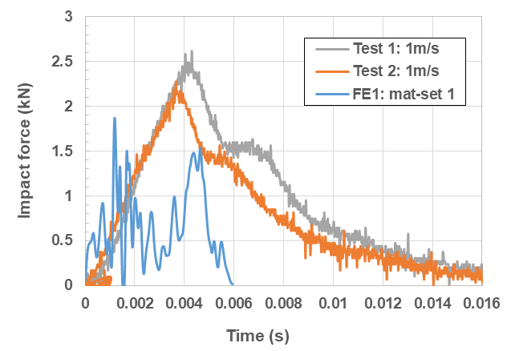 | 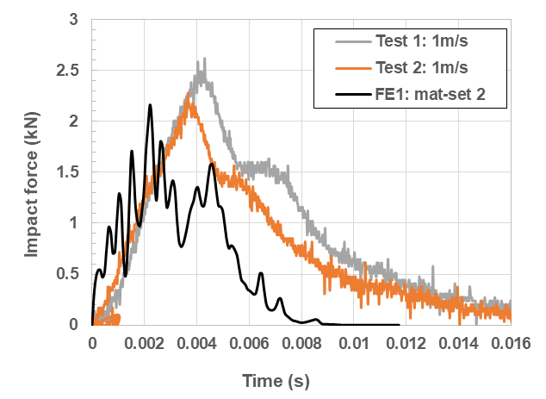
(a) | (b)
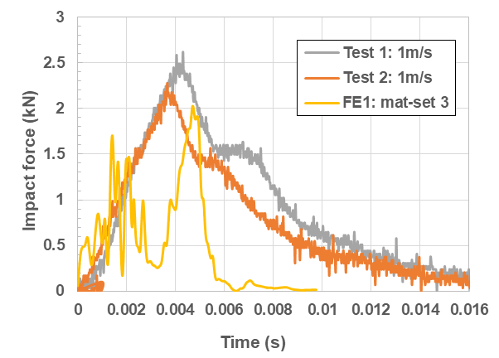 | 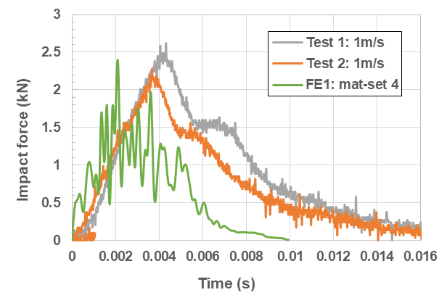
(c) | (d)
Figure 4. Comparison of the impact force versus time curves obtained from the experimental and numerical results under effect of material mechanical parameters in: (a) “mat-set 1”, (b) “mat-set 2”, (c) “mat-set 3”, and (d) “mat-set 4” conditions.

Figure 5 shows the deformation and the damage obtained from both the experimental and the numerical results. The numerical prediction of the deformation and damage contours was extracted at 5.88E-3 seconds during impact, when the impact force decreased to a small level, less than 0.25 kN. The damage areas on the front surface obtained by test and simulation were very close but on the back surface, a relatively larger damage size occurred during test.
Figure 6 shows the local failure profile predicted at the 5.88E-3 seconds using all four material mechanical parameter sets, in which the failed elements were automatically deleted. Major failure modes were shearing, 90° direction tension for the uni-directional core layers, and compression through the thickness due to the low strengths in this direction.
Local element failure was successfully predicted for all the cases except “mat-set 2”. Based on the visual observations during the test, the major force drop happened after the initial cracks propagated away and before they joined together to form a large fracture in the laminate. Similarly, the failure predicted in the models occurred at the moment when the major force drop happened. The model worked very well and gave acceptable predictions on the damage and deformation contours. Fairly good agreement in the force versus displacement curves was obtained between the experimental and numerical results with the material parameters “mat-set 2” and “mat-set 4”.
Discrepancies between the experimental and numerical results could be caused by the existing differences between the actual testing and numerical simulation conditions. For instance, a constant impact velocity can be kept through the impact stage in the simulation, which may not be the case in actual testing. Also, differences in other aspects, such as the material mechanical parameters and displacement boundary conditions, likely exist.
In this section, only the intra-laminar failure of the laminated panel was simulated under the 1 m/s velocity impact condition. Local damage was mainly caused by the shear failure in the thickness and the in-plane directions, as well as the tensile failure of the core plies in through the thickness direction, which also led to limited delamination between plies. This numerical work strongly suggests that relevant failure profiles through the thickness direction should be included in the future experimental tests. The model itself worked very well with fairly good agreement in the force versus time curves using material parameters defined in the “mat-set 2” and “mat-set 4” conditions.
Front surface
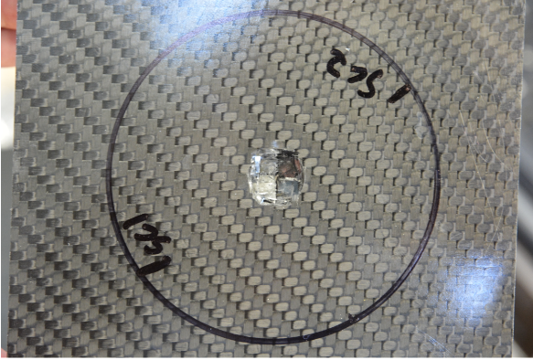
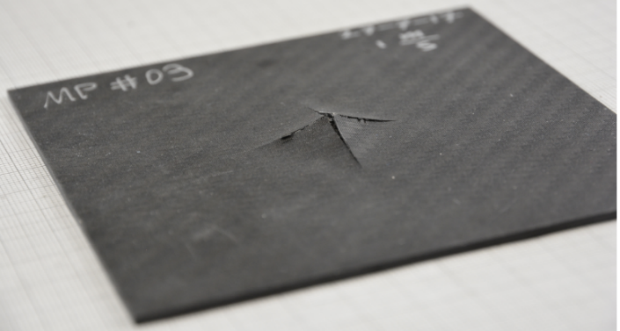
Front surface
(a) Damage obtained from a test
Back surface
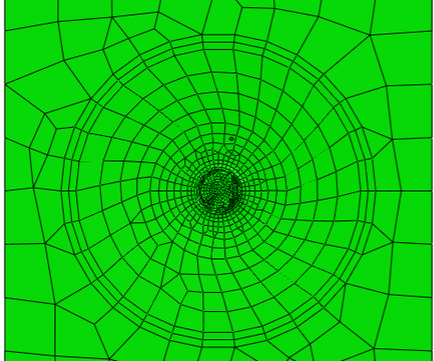
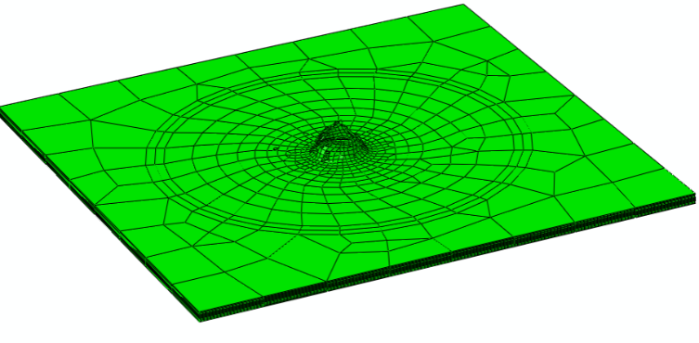
(b) Deformation and damage predicted from the “FE1: “mat-set 3” condition
Back surface
Figure 5. Comparison of full-field deformation and damage contours observed on the front and back surfaces obtained from: (a) a test, and (b) a simulation in the “FE1: mat-set 3” case (no cohesive elements).

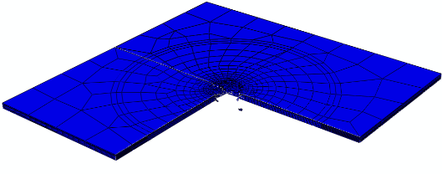
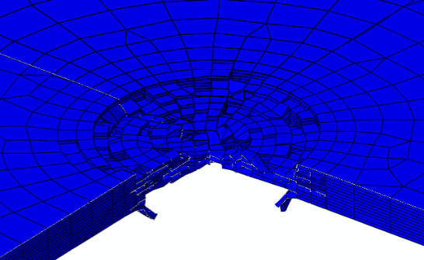

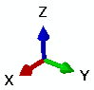

(a) mat-set 1
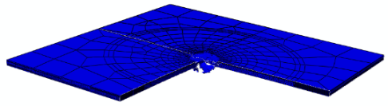
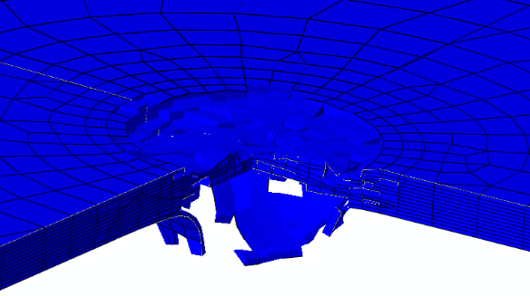
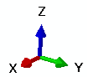

(b) mat-set 2
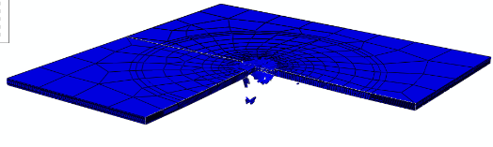
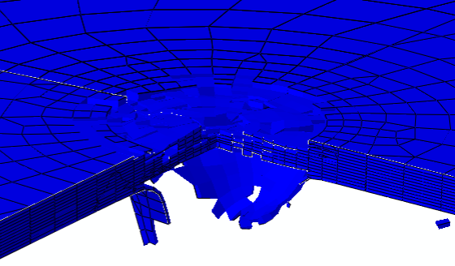
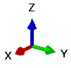

(c) mat-set 3
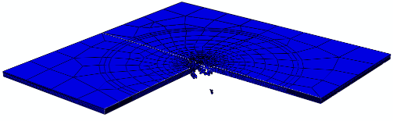
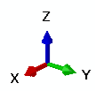
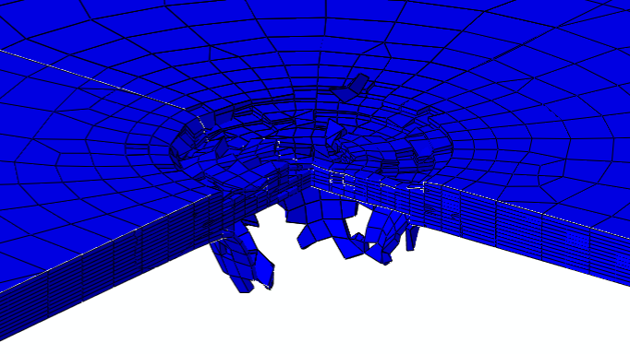

(d) mat-set 4

Figure 6. Local failure induced by the 1 m/s impact velocity predicted using four different material sets.

4. Modelling Impact Response Considering Delamination
Delamination was simulated using cohesive elements. These elements were 5.E−2 mm thick and were located at different interfaces. Three-dimensional solid elements were used to mesh the steel indenter, the panel layers, while the 3D cohesive elements were used to mesh the through the thickness cohesive zones that separated the carbon layers.

4.1. The Meshed Models with Solid Elements and Cohesive Elements
Three models of the 2.2 mm thick panel were created. For each model a specific delamination assessment was combined with the intra-laminar failure mode. The cohesive zone layers, meshed with cohesive elements, were introduced in the following three situations: (i) only a cohesive zone layer imbedded at the panel mid-plane ply interface; (ii) two cohesive zone layers introduced and each at the skin-core interface position; and (iii) a total of eleven cohesive zone layers created inside the panel at every ply-ply interface. Details of this modelling are included in the subsequent subsections.

4.1.1. The panel model with a cohesive zone layer at its mid-plane ply interface
A cohesive zone layer, meshed with cohesive elements, was created at the mid-plane location. The thickness of the cohesive zone layer was assumed to be 0.05 mm, and the thickness of each of the associated two 0⁰ plies was adjusted, from 0.18 mm to 0.155 mm, to maintain the original panel thickness even through a cohesive zone layer was introduced. The same mesh condition was used to mesh the 13-layer 2.2 mm thick panel. A total of 9295 elements were created for this model. These elements were: 8148 linear hexahedral C3D8R stress elements, 432 linear wedge C3D6 stress elements, 679 linear hexahedral COH3D8 cohesive elements, and 36 linear wedge cohesive elements. This model is illustrated in Figure 7. For this evaluation model, “FE2-CohElm1”, there were no mesh changes to the steel indenter. The results obtained utlilizing material set 2, were labelled as “FE2-CohElm1: mat-set 2”, for futher examination in this paper.

4.1.2. Model with two cohesive zone layers at the skin-core interfaces
The two cohesive zone layers, each 0.05 mm in thickness, were introduced between the skin-core interfaces, and the skin thickness was changed from the 0.2 mm to 0.15 mm to keep the panel thickness unaltered. This panel model consisted of a total of 14 layers, as shown in Figure 8. After development it had a total of 10024 elements: 8160 hexahedral C3D8R stress elements; 432 wedge C3D6 stress element; 1360 hexahedral COH3D8 cohesive elements; and 72 wedge COH3D6 cohesive elements. The model with two cohesive zone layers at the skin-core interfaces was labelled “FE2-CohElm2”, and the results obtained utilizing material set 2 were labelled “FE2-CohElm2: mat-set 2” for further examination within this paper.

4.1.3. Model with multiple cohesive zone layers at each layer-layer interfaces
The last model evaluated utilized eleven cohesive zone layers that were meshed with COH3D8 type cohesive elements and created at all the ply to ply interfaces. This model is illustrated in Figure 9. The model was comprised of 23 layers, in which the skin thickness was kept as its original 0.2 mm, while the core layer thickness was reduced to 0.13 mm to maintain a consistent thickness of the panel. The model developed contained 16491 elements: 8172 linear hexahedral C3D8R stress elements; 432 linear wedge C3D6 elements; 7491 hexahedral COH3D8 cohesive elements; and 396 wedge COH3D6 cohesive elements. Using a similar nominclature, the model case was labelled as “FE2-CohElms” and results obtained used material set 2 and were labelled as “FE2-CohElms: mat-set 2”.
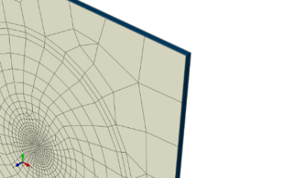
Cohesive zone layer (in red)

Figure 7. The panel model, FE2-CohElm1, consisted of 12 laminar plies and 1 cohesive zone layer located at the panel mid-plane position.

Cohesive zone layers (in red)

Figure 8. The panel model, FE2-CohElm2, consisted of 12 laminar plies and 2 cohesive zone layers located at the panel skin-core interface positions.

Cohesive zone layers (in red)

Figure 9. The 3D panel model, FE2-CohElms, consisted of 12 laminar plies and 11 cohesive zone layers located at all the ply-ply interfaces.

4.2. Failure Behaviour of Cohesive Elements
Cohesive elements used in this investigation were governed by a bilinear traction-separation behaviour that is illustrated schematically in Figure 10. The cohesive traction-separation curve consists of an initial elastic stage followed by a linear softening stage, where $σ_{0}$ is the cohesive interfacial strength; $K$ is the cohesive stiffness; $δ_{0}$ is the displacement at the irreversible interface damage onset position, and $δ_{f}$ is the relative displacement for separation when the traction is degraded to zero. The critical strain energy release rate, fracture toughness, is computed as: $G_{IC}=\frac{1}{2}σ_{0}δ_{f}$. This delamination fracture toughness can be determined by an ASTM standard test [28]. In the modelling evaluation, the cohesive stiffness $K$ was set high enough to eliminate the influence of the introduced cohesive zone (CZ) on the original material property. Zou et al. [29] suggested that the stiffness ought to be in the range of ($fσ_{0}$), (coefficient $f$ = 10⁴–10⁷/mm) in their study of the inter-laminar and intra-laminar damage in filament-wound pipes under quasi-static indentation.
In the current study, material mechanical parameters for the cohesive elements were: density of 10 kg/mm³, 30 MPa cohesive strength, and an assumed cohesive stiffness of $K=$ 5.E+5 (N/mm³). The $K$ level was assigned to all three data fields, $E/{E_{nn}}$, ${G_{1}}/{E_{ss}}$, and ${G_{2}}/{E_{tt}}$; and damage onset was expressed in QUADS damage with a specified nominal interfacial strength in the normal-only mode, first shear direction, and the second shear direction, as defined by Eq. (1). The damage evolution was determined by a mixed mode behaviour equation proposed by Benzeggagh and Kenane (BK) [30], as given in Eq. (2) below using the power of $η$=1.7 and a fracture toughness of 0.188 (N/mm) in normal mode and shear mode in the first direction and the second directions.
$f={\left\{\frac{〈t_{n}〉}{t_{n}^{0}}\right\}}^{2}+{\left\{\frac{t_{s}}{t_{s}^{0}}\right\}}^{2}+{\left\{\frac{t_{t}}{t_{t}^{0}}\right\}}^{2}$ (1)
where $t_{n}^{0}$, $t_{s}^{0}$, and $t_{t}^{0}$ are interfacial cohesive strengths in the normal direction, first shear direction, and the second shear direction, respectively. Note that the damage onset occurs when the quadratic function involving with the stress ratios, f, equals 1.
$G_{eqC}=G_{IC}+\left(G_{IIC}-G_{IC}\right){\left(\frac{G_{II}}{G_{I}+G_{II}}\right)}^{η}$ (2)
where $G_{IC}$ and $G_{IIC}$ are critical fracture toughness in mode I and mode II, respectively.
Note also that automatic element deletion was set up during element meshing. As a result, those failed elements are deleted automatically when their failure threshold is reached.
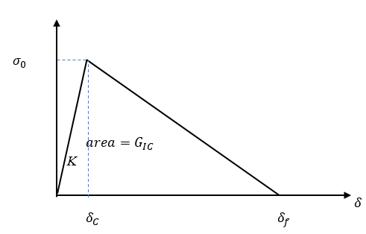
Figure 10. A schematic diagram for a bilinear cohesive traction-separation law.

4.3. Results and Discussion

4.3.1. Profile of the force-time curves obtained from the models with cohesive elements
Three material property sets, “mat-set 2”, “mat-set 3”, and mat-set 4”, were assessed in the simulations. The associated model results were labelled as “FE2-CohElm1: mat-set j”, “FE2-CohElm2: mat-set j”, and “FE2-CohElms: mat-set j”, where j = 2 to 4 refer to the material set used in the simulations.
The predicted force versus time curves are included in Figure 11 along with the experimental results for comparison. Force reversals in the predicted results were densely distributed throughout the entire impact force versus time period. Ignoring the very narrow high force pulses; the force magnitude profile predicted from the “FE2-CohElms” model was the smallest among the three cohesive models evaluated, and the assessment of the “mat-set 4” using the “FE2-CohElms” model was not carried out. The other two cohesive element model cases, “FE2-CohElm1” and “FE2-CohElm2”, provided similar predictions in the force versus time curves. It was also noted that the impact duration was slightly longer using the “FE2-CohElm1” model than in the “FE2-CohElm2” model; while the force magnitude was higher in the “FE2-CohElm 2” model than in the “FE2-CohElm1” model using both the “mat-set 2” and “mat-set 4” material mechanical properties.
The effect of the material mechanical parameters on the force versus time variation profile for each cohesive model is shown in Figure 12. There were high numerical oscillations in the force variation using the cohesive elements. Based on a force variation trend that was estimated using a moving average method, the “FE2-CohElm2” model appears to provide a reasonable prediction among the three assessed models. Furthermore, the two material property sets, “mat-set 2” and “mat-set 4, made the “FE2-CohElm2” model achieved reasonable predictions, in comparison with the experimental results. High force oscillations obtained from numerical analyses were introduced by using cohesive elements. Therefore, these unrealistic extremely high and low peak forces should be excluded and the analysis should be focused on the trends depicted in Figures 11 and 12. It was also noted that in the three “FE2-CohElmi” ($i=$1, 2, s) models, the cohesive zone layers intuitively introduced a weak link between the plies. As a result, the laminated panel models were more susceptible to delamination and the numerical analyses provided a demonstration of realistic parameters that influence ply/ply interface response for impact models.

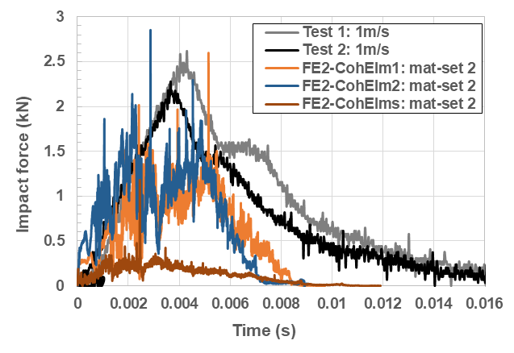 | 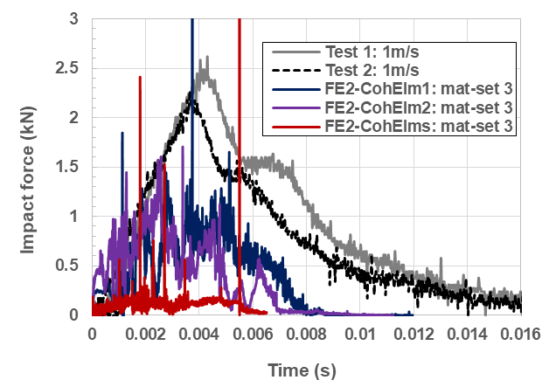
(a) | (b)
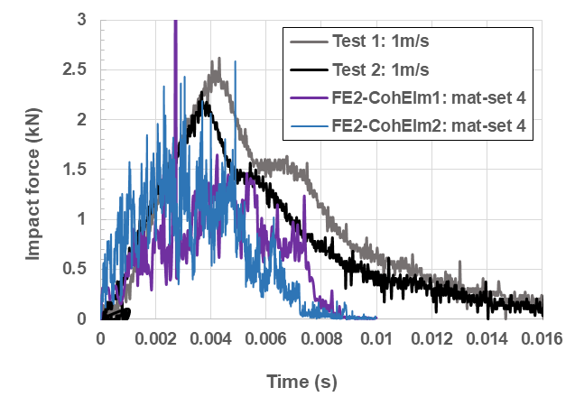
(c)
Figure 11. Comparison of the impact force versus time variation curves obtained from the experimental and the cohesive model results showing the effect of material mechanical parameters using: (a) “mat-set 2”, (b) “mat-set 3”, and (c) “mat-set 4” conditions.

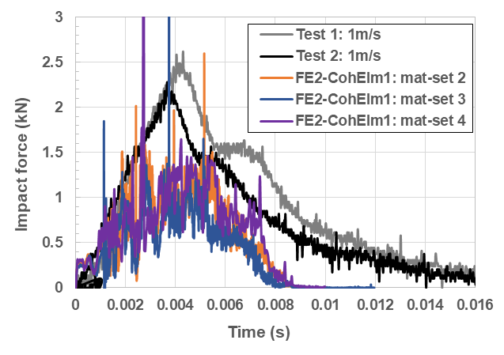 | 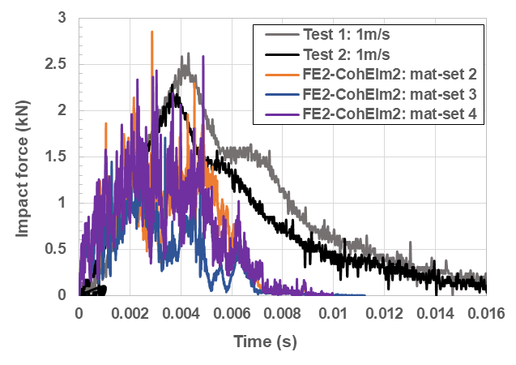
(a) | (b)
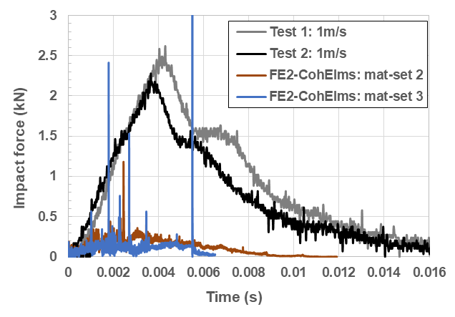
(c)
Figure 12. Comparison of the impact force-time variation curves obtained from the experimental and the cohesive model results showing the effect of material mechanical parameters for: (a) the “FE2-CohElm1” model; (b) the “FE2-CohElm2” model; and (c) the “FE2-CohElms” model.

4.3.2. Damage predicted from the models with cohesive elements
Close-up views of the impact damage and failure predicted by the cohesive element models are shown in Figures 13 to 15. The numerical prediction of the deformation and damage contours was extracted at 0.0058 seconds, when the impact force was decreased to a small level of 0.3 kN. The effect of material mechanical parameters on the damage and the degree of delamination looks reasonable when compared to the testing. In addition to the local area failure, evidence of large delamination at the mid-plane was successfully predicted by the “FE2-CohElm1” model, as shown in Figure 13. Delamination at the two skin-core interfaces was predicted by the “FE2-CohElm2” model, as shown in Figure 14. Multiple delaminations through the panel thickness were successfully predicted by the “FE2-CohElms” model, as shown in Figure 15. Major failure modes were: delamination, shearing, 90⁰ direction tension for the unidirectional core layers, and compression in the through the thickness direction for low strength in this specific direction.

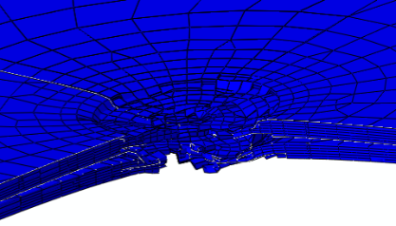
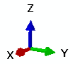
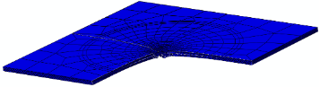

(a) mat-set 2
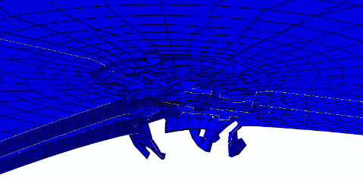
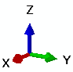
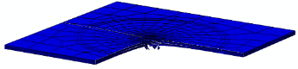

(b) mat-set 3
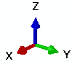
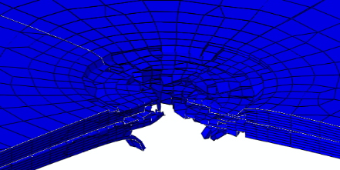
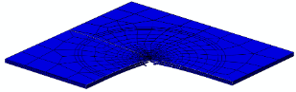

(c) mat-set 4

Figure 13. An evident delamination at the mid-plane combined with intra-laminar failure was predicted by the “FE2-CohElm1” model using the material mechanical parameters defined in the: (a) “mat-set 2”, (b) mat-set 3”, and (c) “mat-set 4” conditions.

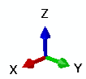
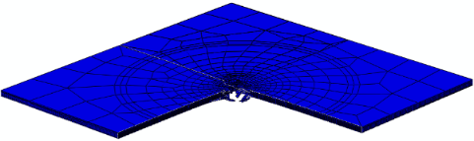
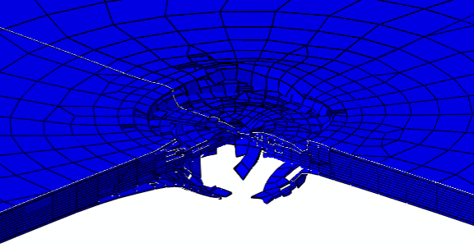

(a) mat-set 2

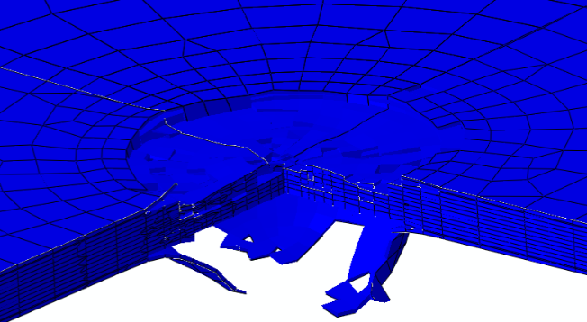
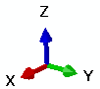
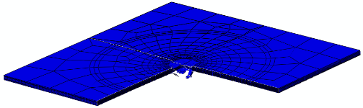

(b) mat-set 3
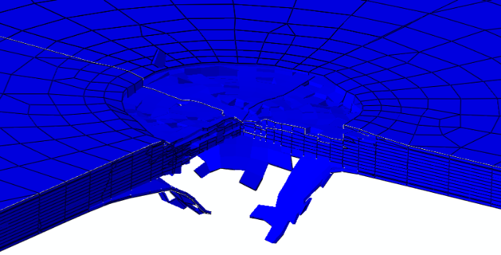
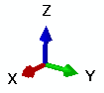
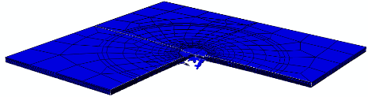

(c) mat-set 4

Figure 14. Delaminations at the skin-core interfaces combined with intra-laminar failure were predicted from the “FE2-CohElm2” model using the material mechanical parameters defined in the: (a) “mat-set 2”, (b) mat-set 3”, and (c) “mat-set 4” conditions..

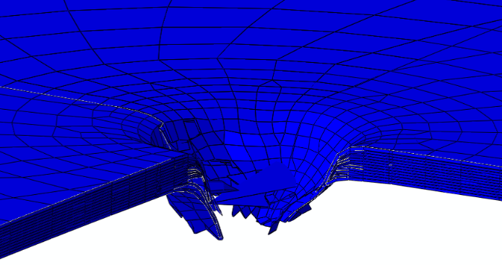

(a) mat-set 2
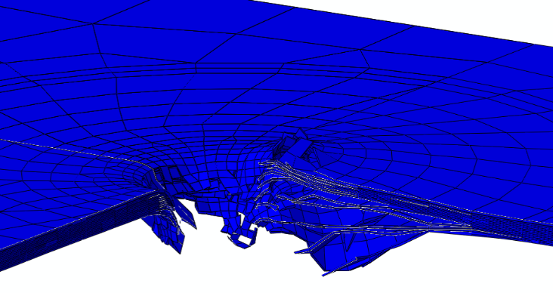
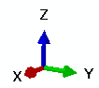

(b) mat-set 3

Figure 15. Multiple delaminations combined with intra-laminar failure were predicted from the “FE2-CohElms” model using the material mechanical parameters defined in the: (a) “mat-set 2” and (b) mat-set 3” conditions.

Three panel models consisting of stress elements and cohesive elements were established to simulate both intra- and inter-laminar failures. These models effectively predicted local failure including delaminations. The major failure modes predicted were: delamination, shearing, 90⁰ direction tension for the uni-directional carbon/epoxy core layers and compression in the thickness direction. Numerical results showed that delaminations could be simulated at the impact region and its adjacent zones similar to experimental results. To improve the prediction accuracy, mechanical parameters of the cohesive elements should be justified using relevant parameters obtained from standard tests.

5. Concluding Remarks
Three-dimensional FE models were created to simulate the impact response of a laminated composite panel in two cases: (i) without delamination, and (ii) with delamination using cohesive elements. Linear elastic behaviour prior to failure was assumed for the composite materials. One of the difficulties for undertaking these simulations is lack of material mechanical data, especially under high strain-rate loading conditions. The available material mechanical parameters given by both the manufacturer’s reference and our in-house tests were derived from quasi-static loading conditions only. Also, damage details throughout the panel thickness at specific locations should be investigated experimentally to support numerical model development to obtain a highly accurate computational prediction capability. It is expected that this effort could contribute to the development of a practical numerical modelling tools to support the design and application of advanced space structures using the cutting-edge composite materials.
Some agreement in the impact force versus time curves was obtained for both situations, compared with the experimental results. There were more force reversals, combined with high force pulses, obtained from the cohesive element models than the layered model without cohesive elements. This was probably due to the continuous failure in the model by separation of the cohesive element nodal pairs. The comparison between the experimental and the numerical results suggests that: (i) material mechanical parameters play a critical role in the failure predictions, and (ii) local delamination could be more accurately predicted with more suitable cohesive parameters.

References
- Ashtonm HR (1996), Damage tolerance and durability testing for F/A-18 E/F composite materials structures. In: Proceedings of 37th AIAA/ASME/ASCE/ AHS/ASC structures, structural dynamics & materials conference, Salt Lake City, UT, April, paper AIAA-96-1320-CP; 1996.
- FAA: AC 20-107B (2010), “Composite aircraft structure”, US Department of Transportation, Federal Aviation Administration (FAA).
- Technology for small spacecraft, International Standard Book number 0-309-05075-8, National Academy Press, Washington, D.C. 1994.
- Lopes C.S., Seresta O., Coquet Y., Gürdal Z., Camanho P.P., Thuis B. (2009), Low-velocity impact damage on dispersed stacking sequence laminates. Part I: Experiments. Compos Sci Technol, 69:926–36.
- Sayer M., Bektas N.B., Sayman O. (2010), An experimental investigation on the impact behavior of hybrid composite plates. Compos Struct, 92(2):1256–62.
- Atas C., Akgun Y., Dagdelen O., Icten B.M., Sarikanat M. (2011), An experimental investigation on the low velocity impact response of composite plates repaired by VARIM and hand layup processes. Compos Struct, 93(3):1178–86.
- Kursun A., Senel M., Enginsoy H.M. (2015), Experimental and numerical analysis of low velocity impact on a preloaded composite plate. Adv Eng Softw, 90:41–52.
- Mishra A., Naik N.K. (2010), Failure initiation in composite structures under low-velocity impact: analytical studies. Compos Struct, 92(2):436–44.
- Xiao S.S., Chen P.H., Ye Q. (2014), Prediction of damage area in laminated composite plates subjected to low velocity impact. Compos Sci Technol, 98:51–6.
- Singh H., Mahajan P. (2016), Analytical modeling of low velocity large mass impact on composite plate including damage evolution. Compos Struct, 149:79–92.
- Yu Z.F., Gao S.J. (2016), Increase of contact radius due to deflection in low velocity impact of composite laminates and prediction of delamination threshold load. Compos Struct, 147:286–93.
- Liu P.F., Liao B.B., Jia L.Y., Peng X.Q. (2016), Finite element analysis of dynamic progressive failure of carbon fiber composite laminates under low velocity impact. Compos Struct, 149:408–22.
- Maio L., Monaco E., Ricci F., Lecce L. (2013), Simulation of low velocity impact on composite laminates with progressive failure analysis, Compos Struct, 103:75–85.
- Feng D., Aymerich F. (2014), Finite element modelling of damage induced by low-velocity impact on composite laminates. Compos Struct, 108:161–71.
- Shi Y., Pinna C., Soutis C. (2014), Modelling impact damage in composite laminates: a simulation of intra-and inter-laminar cracking. Compos Struct, 114:10–9.
- Caputo F., Luca A.D, Lamanna G., Borrelli R., Mercurio U. (2014),. Numerical study for the structural analysis of composite laminates subjected to low velocity impact. Compos B, 67:296–302.
- Liu P.F., Gu Z.P., Peng X.Q., Zheng J.Y. (2015), Finite element analysis of the influence of cohesive law parameters on the multiple delamination behaviors of composites under compression. Compos Struct, 131:975–86.
- May M. (2015), Numerical evaluation of cohesive zone models for modeling impact induced delamination in composite materials. Compos Struct, 133:16–21.
- Zhang J.K., Zhang X. (2015), An efficient approach for predicting low-velocity impact force and damage in composite laminates. Compos Struct, 130:85–94.
- Xu Z., Yang F., Guan Z.W., Cantwell W.J. (2016), An experimental and numerical study on scaling effects in the low velocity impact response of CFRP laminates. Compos Struct, 154:69–78.
- Schwab M., Pettermann H.E. (2016), Modelling and simulation of damage and failure in large composite components subjected to impact loads. Compos Struct, 158:208–16.
- Hashin Z. (1980), Failure criteria for unidirectional fiber composite. J Appl Mech, 47:329–34.
- Murakami S. (1988), Mechanical modeling of material damage. J Appl Mech, 55:280–6.
- Lapczyk I., Hurtado J.A. (2007), Progressive damage modeling in fiber reinforced materials. Compos A, 38(11):2333–41.
- Zhang C., Duodu E.A., Gu J.(2017), Finite element modeling of damage development in cross-ply composite laminates subjected to low velocity impact, Compos Struct, 173:219–27.
- Bogenfeld R., Kreikemeier J., Wille T. (2018), Review and benchmark study on the analysis of low-velocity impact on composite laminates. Eng Failure Analysis, 86:72-99.
- Li G., Renaud G., Zhang Y. (2016), Explicit model development for simulating impact response of Kevlar panels, NRC Aerospace technical report, LTR-SMM-2016-0084.
- Standard test method for mode I interlaminar fracture toughness of unidirectional fiber-reinforced polymer matrix composites, ASTM Designation D5528-01 (Reapproved 2007).
- Zou Z., Reid S.R., Li S., Soden P.D. (2003), Modelling interlaminar and intralaminar damage in filament-wound pipes under quasi-static indentation. J Compos Mater, 36(4):477–99.
- Benzeggagh M.L., Kenane M. (1996), Measurement of mixed-mode delamination fracture toughness of unidirectional glass/epoxy composites with mixed-mode bending apparatus. Compos Sci Technol, 56:439-449.
- Puck A., Schurmann H. (1998), Failure analysis of FRP laminates by means of physically based phenomenological models, Compos Sci Technol, 58:1045-1067.

∗ Corresponding author. Tel: (613) 990-4989; E-mail: Gang.Li@nrc-cnrc.gc.ca (Gang Li)

